Contents Page No.

1. Main Report 1
  - Introduction To Project 2
  - Objective And Scope Of The Project 3
  - Technical Background 4
  - Flow Chart 25
2. Project Code 26
3. Screens 90
4. User Manual 99
5. Annexure: 107
  - Background Of The Organization 108
  - Bibliography 109

Main Report

Introduction:

The efficiency, clarity and complexity of a programme for the solution of a given the selected data structures. It is the purpose of this project to present the most important data structures, to explain concepts with graphically. Under what conditions which data structures can be used most effectively and to indicate which programming techniques are most desirable for working with a particular data structure.

This project “Introduction To Data Structures” explains concepts of data structures, searching and sorting techniques with graphically for better understanding to who are beginners of data structures.

In the study of data structures, it is necessary not only to define the concept of a data structure itself but also state how the data structure can be stored and manipulated, with this purpose in mind, several considerations are appropriate. First, using the general definitions of the concept of a data structure and illustrating the concepts with graphically. Methods of storing structures can be presented. The actual description of algorithms for manipulating data structures stored in a computer is given using ‘c’ language.

The main feature of this project is the user can input his/her relevant data for illustrations. Help gives complete technical background and general programs of these Data Structures. You can see any data structure theory and general programs in this project using help option when you are working with particular data structure.

Objective & Scope Of The Project:

The purpose of this project “Introduction To Data Structures“ is better understanding concepts of data structures and its manipulations.

This project explains most important data structures and its operations step by step with graphics. This project also explains most important searching and sorting techniques with graphics.

The selected data structures and searching and sorting techniques are linear search, binary search, linear sort, binary sort and insertion sort, singly linked list, doubly linked list, stack, queue and its operations, binary tree and its traversals, infix to prefix, infix to post fix conversions and evaluation of postfix expression. All these explained with graphics. The actual definition of structures and algorithms and concepts is provided in online help.

The project has many features to be used with friendly environment. This project provides graphical user interface environment so the user can use this software very easily. In this project all menus provided with hotkeys. The hotkeys all are underlined for easy recognition. The user can select an option with up/down arrow keys followed by enter key or appropriate hotkey.

By using of this software the users definitely get better idea about particular data structure and its operations.
Theoretical Background:

The theoretical background of the data structures and techniques used in this project is briefly given here.

Searching:

A user may wish to retrieve a record with a particular value of some key, the searching algorithms accomplish this task.

Sequential Search:
This is the simplest way of searching in which search is to begin at one end of the list scan down it until the desired key is found or the other end is reached.

/* Sequential Search: contiguous version */
int sequentialsearch(list_type list, key_type target)
{
int location;
for(location=0,location<list.count;location++)
if(EQ(list.entry[location]key,target))
return location;
return –1;
}

The average number of comparisons done by sequential search is the successful case is = ½^{(n+1)}

Binary Search:
If the file being searched is ordered by increasing or decreasing values, then this method is applicable. First, compare the item with one in the center of the list and then restrict out attention to only the first or second half of the list, depending on whether the item comes before of after the control one. In this way, at each step reduce the length of the list to be searched by half. Binary search is good for contiguous lists.

/* Binary search: Contiguous version */
int Binary(list_type list, key_type target)
{
int top, bottom, middle;
top = list.count-1;
bottom = 0;
while(top>=bottom){
middle=(top+bottom)/2;
if(EQ(list.entry[middle].key,target))
return middle;
else if(LT(list.entry[middle].key,target))
bottom = middle+1;
else
top = middle +1;
}
return-1;
}

In the worst case binary search requires 0(log n) comparisons.

Sorting:

Sorting an array into ascending order means rearranging the values in the array so that the elements progressively increase in value from the smallest to the largest. By the end of such a sort, the minimum value will be contained in the first location of the array,while the maximum value will be found in the last location of array,with values that progressively increase in between.This prosses rearranging the values in some known order is called 'SORTING'.

Leniar Sort:-
if we wanted to sort an array of n elements into assending order,we could do so by performing a successive comparison of each of the elements of the array. We could begin by comparing the first element in the array against the second. If the first element were greater in value than the second,then we could simply "swap" the two
values in the array;that is,exchange the values contained in these two locations.

Next,we could campare the first element in the array against the third element in the array. Once again,if the first value were greater than the third,we could exchange these two values. Otherwise we would leave them alone.Now we would have the smallest of the first three elements contained in the first location of the array.

If we repeated the above process for the remaining elements in the array comparing the first element against each successive element,and exchanging their values if the former were larger than the latter then the smallest value of the entire array would be in the first location of the array by end of the process.

If we now did the same thing with the second element of the array,that is compared it against the third element,then against the fourth,and so on,and if we exchanged any values that were out of order we would then end up with the next smallest value contained in the second location of the array when the process was completed.

It should now be clear how we can go about sorting the array by performing these successive comparisons and exchanges as needed. The process will stop after we have compared the next-to-last element of the array against the last and have interchanged their values if required,At that point,the entire array will have been sorted into ascending order.

/* Leniar Sort Example */

#include<stdio.h>
#include<conio.h>

main()
{
int array[10],i,j,temp;

clrscr();

for(i=0;i<10;i++)
{
printf("Enter A Number ");
scanf("%d",&array[i]);
}

clrscr();

for(i=0;i<10;i++)
printf("%d ",array[i]);

printf("\n");

for(i=0;i<10;i++)
for(j=i+1;j<10;j++)
if(array[i]>array[j])
{
temp=array[i];
array[i]=array[j];
array[j]=temp;
}

for(i=0;i<10;i++)
printf("%d ",array[i]);

getch();

}

Bubble Sort:-
if we wanted to sort an array of n elements into assending order,we could do so by performing a successive comparison of each of the elements of the array. We could begin by comparing the first element in the array against the second. If the first element were greater in value than the second,then we could simply "swap" the two values in the array;that is,exchange the values contained in these two locations.

Next,we could campare the second element in the array against the third element in the array. Once again,if the second value were greater than the third,we could exchange these two values. Otherwise we would leave them alone.Now we would have the largest of the first three elements contained in the third location of the array.

If we repeated the above process for the remaining elements in the array comparing the each element against next successive element,and exchanging their values if the former were larger than the latter then the largest value of the entire array would be in the last location of the array by end of the process.

If we now did the same thing with the first element of the array,that is compared it against the second element,then second against the third ,and so on,and if we exchanged any values that were out of order we would then end up with the next largest value contained in the before one location of last location of the array when the process was completed.

It should now be clear how we can go about sorting the array by performing these successive comparisons and exchanges as needed.The process will stop after we have compared the first-to-last-1 element of the array against the last and have interchanged their values if required,At that point,the entire array will have been sorted into ascending order.

/* Bubble Sort Example */

#include<stdio.h>
#include<conio.h>

main()
{
int array[10],i,j,temp;

clrscr();

for(i=0;i<10;i++)
{
printf("Enter A Number ");
scanf("%d",&array[i]);
}
clrscr();

for(i=0;i<10;i++)
printf("%d ",array[i]);

printf("\n");

for(i=0;i<10;i++)
for(j=0;j<9-i;j++)
if(array[j]>array[j+1])
{
temp=array[j];
array[j]=array[j+1];
array[j+1]=temp;
}

for(i=0;i<10;i++)
printf("%d ",array[i]);

getch();

}

Insertion Sort:-
The insertion sort inserts the elements in sorted order at time of element insertion into the array.so need to rearrange the values in the array.Suppose we want ot insert a value into the array, first it search sequentialy form back wards in the array.

First it compare with last element and new element,if new last element is greater than new element it will shift the last element into one location back in array. Next it will compare with second largest value.and so on.

This process will continue upto new element is smaller than the compared element.If the new element is larger than the compared element it will stop the search and insert the new element in to the next location of last compared element.

So in Insertion sorting at the time of insertion of elements it will be sorted.

/* Insertion Sorting Example */

#include<stdio.h>
#include<conio.h>

int main(void)
{
int array[10],i=0,k,num;
k=-1;
while(k<9)
{
printf("Enter a Number");
scanf("%d",&num);

k++;

while(array[i]>num&&i>=0)
{
array[i+1]=array[i];
i--;
}

i++;

array[i]=num;

i=k;
}

for(i=0;i<10;i++)
printf("%d ",array[i]);

getch();
}

Linked Lists:

Linked list is list in which each entry will be a structure containing not only the items of information but also a pointer to the next structure in the list. The use of links requires more storage but provide greater flexibility. There is no need to keep an explicit counter of the number of nodes in the list. Overflow in not a problem until the computer memory exhausted. The contiguous storage is generally preferable when structures are individually very small. Linked list provides superior when the structures are large.

Singly Linked List:
A linked list in which each node contains one link, that link point to the next node in the list is called singly linked list. The list traversals can be made in only one direction only.

Doubly Linked list:
A linked list in which each node contains two links, one to the next node in the list and one to the preceding node. It is not possible to move either direction through the list while keeping only one pointer. With a doubly linked list. Traversals in either direction, insertions and deletions form arbitrary position in the list can be programmed with out difficulty, the cost of a doubly linked list, is the extra space required in each node for a second link.

We have the capability of dynamically allocating and freeing a variable and these dynamic variables can be used to implement linked lists. A linked list consists of a set of nodes, each of which has two fields:
An information field and a pointer to the next node in the list. In addition, an external pointer points to the first node in the list. We use pointer variables to implement list pointers. Thus, we define the type of a pointer and a node by

Struct node{
int info;
struct node *next;
};
typedef struct node *NODEPTR;

A node of this type is identical to the nodes of the array implementation except that the next field is a pointer (containing the address of the next node in the list ) rather than an integer(containing the index with in an array where the next node in the list is kept).

NODEPTR getnode()
{
NODEPTR p;
P = (NODEPTR) malloc(sizeof(struct node));
return (p);
}

freenode(NODEPTR p)
{
free(p);
}

The programmer need not be concerned with managing available storage. There is no longer a need for the pointer avail (pointing to the first available node), since the system governs the allocating and freeing of nodes and the system keeps track of the first available node. There is no test in getnode to determine whether overflow has occurred. Because such a condition will be detected during the execution of the malloc function and is system dependent.

The procedures insafter(p,x) and delafter(p,px) are presented below using the dynamic implementation of a linked list. Assume that list is a pointer variable that points to the first node of a list(if any) and equals NULL in the case of an empty list.

insafter(NODEPTR P, int x)
{
NODEPTR q;
if(p == NULL) {
printf(“void insertion\n”);
exit(1);
}
q = getnode();
q->info = x;
q->next = p->next;
p->next = q;
}

delafter(NODEPTR P, int *px)
{
NODEPTR q;
if((p == NULL) ||(p->next == NULL)){
printf(“void deletion\n”);
exit(1);
}
q = p->next;
*px = q->info;
p->next = q->next;
freenode(q);
}

Stacks:
A stack is an ordered list in which all insertions and deletions are made at one end. This end is called the top. If elements are E,D,C,B,A (in order) then first element to be removed form the stack is A. Stacks are also known as LIFO (Last In First Out) list. The simplest way to implement a stack is to use a one dimensional array of n elements.

A stack is an ordered collection of items, and C already contains a data type that is an ordered collection of items the array. Whenever a problem solution calls for the use of a stack, therefore, it is tempting to begin a program by declaring a variable stack as an array. However, a stack and an array are two entirely different things. The number of elements in an array is fixed and is assigned by the declaration for the array. In general, the user cannot change this number. A stack, is fundamentally a dynamic object whose size is constantly changing as items are popped and pushed.

However, although an array cannot be a stack, it can be the home of a stack, i.e. an array can be declared large enough for the maximum size of the stack. During the course of program execution, the stack can grow and shrink within the space reserved for it. One end of the array is the fixed bottom of the stack, while the top of the stack constantly shifts as items are popped and pushed. Thus, another field is needed that, at each point during program execution, keeps track of the current position of the top of the stack.

A stack in C may therefore be declared as a structure containing two objects; an array to hold the elements of the stack, and an integer to indicate the position of the current stack top within the array. This may be done for a stack of integers by the declarations.

#define STACKSIZE 100
struct stack{
int top;
int items[STACKSIZE];
};

The possibility of underflow must be considered in implementing the pop operation, since the user may inadvertently attempt to pop an element form an empty stack. Such an attempt is illegal and should be avoided. However, if such an attempt should be made the user should be informed of the underflow condition. We therefore introduce a function pop that performs the following three actions:
- If the stack is empty, print a warning message and halt execution.
- Remove the top element form the stack.
- Return this element to the calling program.

Assume that the stack consists of integers, so that the pop operation can be implemented as a function. This would also be the case if the stack consisted of some other type of simple variable. However, if a stack consists of a more complex structure e.g., a structure or union, the pop operation would either be implemented as returning a pointer to a data element of the proper type.

int pop(struct stack *ps)
{
if(empty(ps)){
printf(“stack underflow”);
exit(1);
}
return (ps->items[ps->top--]);
}

void push(struct stack *ps, int x)
{
if(ps->top ==STACKSIZE-1){
printf(“stack overflow”);
exit(1);
}
else
ps->items[++(ps->top)]=x;
return;
}

Queues:

A Queue is an ordered list in which all insertions take place at one end called the rear and all deletions take place at the other end called the front. In queues requires that the first element to be removed is the first one inserted. Thus Queues are known as FIFO(First In First Out) lists.

A queue is represented in C by using an array to hold the elements of the queue and to use two variables, front and rear, to hold the positions within the array of the first and last elements of the queue.
A queue of integers may be declared and initialized by

#define MAXQUEUE 100
struct queue{
int items[MAXQUEUE];
int front, rear;
};
struct queue q;
q.front = q.rear = MAXQUEUE-1;

q.front and q.rear are initialized to the last index of the array, rather than to –1 or 0, because the last element of the array immediately precedes the first one within the queue under this representation, since q.rear equals q.front, the queue is initially empty.

The empty, remove, insert functions may be codes as

int empty(struct queue *pq)
{
return ((pq->front == pq->rear)?1:0);
}

int remove(struct queue *pq)
{
if(empty(pq)){
printf(“queue underflow”);
exit(1);
}
if(pq->front == MAXQUEUE-1)
pq->front=0;
else
pq->front++;
return (pq->items[pq->front]);
}

void insert(struct queue *pq, int x)
{
if(pq->rear == MAXQUEUE-1)
pq->rear=0;
else
(pq->rear)--;
if(pq->rear == pq->front){
printf(“queue overflow”);
exit(1);
}
pq->items[pq->rear]=x;
return;
}

Infix, Postfix, And Prefix:

Consider the sum of A and B. We think of applying the operator “+” to the operands A and B and write the sum as A + B. This particular representation is called infix. There are two alternate notations for expressing the sum of A and B using the symbols A,B and +. There are
+AB prefix
AB+ postfix
The prefixes “pre-“, ”post-“ and “in-“ refer to the relative position of the operator with respect to the two operands. In prefix notation the operator precedes the two operands, in postfix notation the operator follows the two operands, and in infix notation the operator is between the two operands. The prefix and postfix notations are not really as awkward to use as they might at first appear. e.g., a C function to return the sum of the two arguments A and B is invoked by add(A,B) .The operator add precedes the operands A and B.

Examples (i)
Infix Postfix
A+B AB+
A+B-C AB+C-
(A+B)*(C-D) AB+CD-*
(ii)
Infix Prefix
A+B +AB
A+B-C +-ABC
(A+B)*(C-D) *+AB-CD

/* To check given expression is valid or not. */

int validexp(char *s)
{
int od=0,or=0,i,j=0;
char exp[20];

for(i=0;s[i]!=0;i++)
{
if(s[i]!='['&&s[i]!=']'&&s[i]!='{'&&s[i]!='}'&&s[i]!='('&&s[i]!=')')
{
if(operand(s[i]))
{
od++;

if(od-1!=or)
return 0;
}
else
or++;
}
else
{
if(s[i]==']')
if(exp[j]!='[')
return 0;
else
{
j--;
continue;
}

if(s[i]=='}')
if(exp[j]!='{')
return 0;
else
{
j--;
continue;
}
if(s[i]==')')
if(exp[j]!='(')
return 0;
else
{
j--;
continue;
}

j++;
exp[j]=s[i];

} }
if(od-1!=or)
return 0;

if(j>0)
return 0;
return 1;
}

/* Example for infix to prefix expression */

#include<stdio.h>
#include<conio.h>

main()
{
char infix[30];
int i;
struct stack s1,s2;

s1.top=-1;
s2.top=-1;

clrscr();

printf("Enter infix expression");
scanf("%s",infix);

if(!validexp(infix))
{
printf("NOT A VALID EXPRESSION");
exit();
}

for(i=0;infix[i]!=0;i++);

for(i=i-1;i>=0;i--)
{

if(operand(infix[i])
{
push(&s1,infix[i]);
continue;
}

if(infix[i]=='}'||infix[i]==']'||infix[i]==')')
{
push(&s2,infix[i]);
continue;
}

if(infix[i]=='{'||infix[i]=='('||infix[i]=='[')
{
while(top(&s2)!='}'&&top(&s2)!=']'&&top(&s2)!=')')
push(&s1,pop(&s2));
pop(&s2);
continue;
}

while(precedence(infix[i],1)<=precedence(top(&s2),1))
push(&s1,pop(&s2));

push(&s2,infix[i]);
}

while(!empty(&s2))
push(&s1,pop(&s2));

while(!empty(&s1)
printf("%c",pop(&s1));

getch();
}

/* Example for infix to postfix expression */

#include<stdio.h>
#include<conio.h>

main()
{
int i;
char infix[30];
struct stack s1;

s1.top=-1;

clrscr();

printf("Enter infix expression");
scanf("%s",infix);

if(!validexp(infix))
{
printf("NOT A VALID EXPRESSION");
exit();
}

for(i=0;infix[i]!=0;i++)
{

if(operand(infix[i])
{
printf("%c",infix[i]);
continue;
}

if(infix[i]=='{'||infix[i]=='['||infix[i]=='(')
{
push(&s1,infix[i]);
continue;
}

if(infix[i]=='}'||infix[i]==')'||infix[i]==']')
{
while(top(&s1)!='{'&&top(&s1)!='['&&top(&s1)!='(')
printf("%c",pop(&s1));
pop(&s2);
continue;
}

while(precedence(infix[i],0)<=precedence(top(&s1),0))
printf("%c",pop(&s1));

push(&s1,infix[i]);
}

while(!empty(&s1)
printf("%c",pop(&s1));

getch();
}

/* Evaluation of postfix Expression */

#include<stdio.h>
#include<conio.h>

main()
{
int i,od1,od2,ans;
char postfix[30];
struct stack s;

s.top=-1;

clrscr();

printf("Enter postfix expression ");
scanf("%s",postfix);

for(i=0;postfix[i]!=0;i++)
{
if(operand(prefix[i]))
{
push(&s,prefix[i]-48)
continue;
}

od2=pop(&s);
od1=pop(&s);

ans=evalexp(od1,od2,prefix[i]);
push(&s,ans);
}

printf("Expression value is %d",pop(s));

getch();
}

/* To do arithamatic operations */

int evalexp(int od1,int od2,char or)
{
switch(or)
{
case '+':
return(od1+od2);
case '-':
return(od1-od2);
case '*':
return(od1*od2);
case '/':
return(od1/od2);
case '%':
return(od1%od2);
}
return 0;
}

/* To check given charecter is operand or not. */

int operand(char ch)
{
if(ch>='0'&&ch<='9'||ch>='a'&&ch<='z'||ch>='A'&&ch<='Z')
return 1;
else
return 0;
}

/* To get precedence of given operator.
mode 0 for postfix,mode 1 for prefix */

int precedence(char ch,int mode)
{
if(ch==']'||ch=='}'||ch==')')
{
if(mode==0)
return 1; //postfix
else
return 10; //prefix
}

if(ch=='*'||ch=='/'||ch=='%')
return 8;

if(ch=='-'||ch=='+')
return 4;

if(ch=='('||ch=='['||ch=='{')
{
if(mode==0)
return 10;
else
return 1;
}
return 0;
}

Binary Tree:

Tree is defined as a set of vertices such that
- There is a sequence of edges form any vertex to any other.
- There are no circuts, that is, no paths starting from a vertex and returning to the same vertex.

A binary tree is a finite set of elements that is either empty or is partitioned into three disjoint subsets. The first subset contains a single element called the root of the tree. The other two subsets are themselves binary trees, called the left and right subtrees of the original tree. A left or right subtree can be empty. Each element of a binary tree is called a node of the tree.

If A is root of a binary tree and B is the root of its left or right subtree, then A
is said to be the father of B and is said to be the left or right son of A. A node that has no sons is called a leaf. Two nodes are brothers if they are left and right sons of the same father.

If every nonleaf node in a binary tree has nonempty left and right subtrees, the tree is termed a strictly binary tree. A strictly binary tree with n leaves always contains 2n-1 nodes.

Common operation is to 'traverse' a binary tree;that is, to pass through the tree, enumerating each of its nodes once. We may simply wish to print the contents of each node as we enumerate it, or we may wish to process it in some other fashion. In either case, we speak of visiting each node as it is enumerated.

The order in which the nodes of a linear list are visited in a traversal is clearly form first to last.However,there is no such natural linear order for the nodes of a tree. Thus, different orderings are used for traversal in different cases. We shall define three of these traversal methods.In each of these methods,nothing need be done to traverse an empty binary tree. The methods are all defined recursively,so that traversing its left and right subtrees. The only difference among the methods is the order in which these three operations are performed.

To traverse a nonempty binary tree in preorder we perform the follwing three operations:
1.Visit the root.
2.Traverse the left subtree in preorder.
3.Traverse the right subtree in preorder.

To traverse a nonempty binary tree in inorder:
1.Traverse the left subtree in inorder.
2.Visit the root.
3.Traverse the right subtree in inorder.

To traverse a nonempty binay tree in postorder:
1.Traverse the left subtree in postorder.
2.Traverse the right subtree in postorder.
3.Visit the root.

/*Binary tree structure definition */

struct node
{
int info;
struct node *left,*right;
};

/* Binary tree preorder travarsal */
void preorder(node *p)
{

if(p==0)
return;

printf("%d ",p->info);
preorder(p->left);
preorder(p->right);

}

/* Binary tree inorder traversal */
void inorder(node *p)
{

if(p==0)
return;

inorder(p->left);
printf("%d ",p->info);
inorder(p->right);
}

/*binary tree postorder traversal */
void postorder(node *p)
{
if(p==0)
return;

postorder(p->left);
postorder(p->right);
printf("%d ",p->info);

}

/* Binary tree creation */
node *create(node *head)
{
node *p,*q;
int x;

printf("Enter info ");
scanf("%d",&x);

if(head==0)
{
head=(node *)malloc(sizeof(node));
head->info=x;
head->left=0;
head->right=0;
}
while(1)
{
p=head;
printf("Enter info(0 exit) ");
scanf("%d",&x);
if(x==0)
break;
while(p!=0&&p->info!=x)
{
q=p;
if(p->info>x)
p=p->left;
else
p=p->right;
}
if(q->info>x)
{
q->left=(node*)malloc(sizeof(node));
q->left->info=x;
q->left->left=0;
q->left->right=0;
}
if(q->info<x)
{
q->right=(node*)malloc(sizeof(node));
q->right->info=x;
q->right->left=0;
q->right->right=0;
}

if(q->info==x)
{
printf("Duplicate Node");
}
}
return head;
}

/* Application used header files */

#include<stdio.h>
#include<conio.h>
#include<graphics.h>
#include<dos.h>
#include<bios.h>
#include<process.h>
#include<malloc.h>
#include<process.h>

/* Application used data structures */

struct listnode
{
int num,padd,nadd,add;
struct listnode *pre,*next;
};

struct q
{
int array[20];
int rear,front;
};

struct stack
{
int array[20];
int top;
};

struct node
{
int info;
int x,y;
struct node *left,*right;
};

typedef struct node node;
typedef struct q q;
typedef struct stack stack;

/* Applicaition used functions prototypes*/

void init(void);
void searchingwindow(void);
void sortingwindow(void);
void linkedlistwindow(void);
void stackwindow(void);
void queuewindow(void);
void spacewindow(void);
void treewindow(void);
void contentwindow(void);
void listwindow(int i);
int swaping(int array[10],int i,int j,int flag);
void titlebar(char *s,int bcolor,int color);
void drawmenu(char array[10][20],int num,char *s,int i,int p[10],int mode,int color);
int mkey(int num,char *s,char array[10][20],int p[10],char message[10][70],int color);
void drawlable(int pos,int p,char *s);
void drawbox(int array[],int k,int j);
void drawarrow(int pos,int color);
int getdata(int x,int y,int j,char *s);
int strlen(char s[]);
int tolower(int ch);
int quit(void);

void linearsearch(void);
void binarysearch(void);

void lenearsort(void);
void bubblesort(void);
void insertionsort(void);
void drawqpoint(int x,int y,int size,int pos,int color,int mode);
void drawq(int x,int y,int size);

void drawstack(int x,int y,int size,int color);
void drawpointer(int x,int y,int size,int top,int color);
void stackdisplay(int x,int y,int size,stack *s,int pre);
void push(int x,int y,int size,stack *s,int pre,char c);
int pop(int x,int y,int size,stack *s,int mode,int pre);
int full(int size,int top);
int empty(int top);

void drawpoint(int x,int y,int size,int pos,int color,int mode);
void drawq(int x,int y,int size);
void displayq(int x,int y,int size,q *s);
void insertq(int x,int y,int size,q *s);
void deleteq(int x,int y,int size ,q *s);

void treedisplay(node *head ,int x, int y);
void freetree(node *p );
void preorder(node *p,int *x);
void inorder(node *p,int *x);
void postorder(node *p,int *x);
node *create(void);

void drawnode(int x,int y,struct listnode *p,int i);
void llink(int x,int y);
void rlink(int x,int y);
void llinelink(int x,int y);
void rlinelink(int x,int y);
void firstlink(void);
void dmlink(int x,int y);
void d5link(int x,int y);
void nlink(int x,int y,int i);
void d4link(int x,int y);
void newlink(int x,int y,int i);
void display(struct listnode *p,int i);
struct listnode *createlink(struct listnode *head,int *address,int t);
struct listnode *insertnode(struct listnode *head,int *address,int t);
struct listnode *dellink(struct listnode *head,int t);
void freelink(struct listnode *head);

void getinfix(int x,int y,char infix[],char *s,int mode);
int operand(char ch);
int validexp(char *s);
int precedence(char ch,int mode);
void prefix(void);
void postfix(int mode);
int notalpha(char ch);
int evalexp(int od1,int od2,char or);
void opmessage(int x,int y,char c,char *s,int color);

void help(char *name);

void titlewindow(void);
void logo(void);

int buybuy(void);

/* Application starting or main program */

int main()
{
init();
titlewindow();
cleardevice();
contentwindow();
getch();
closegraph();
return 0;
}

/* Initializes the graphics system */

void init(void)
{
int gd=DETECT,gm;
initgraph(&gd,&gm,"");
}

/* Appliction title display */

void titlewindow(void)
{

int i;

setcolor(RED);

settextstyle(TRIPLEX_FONT,HORIZ_DIR,5);
outtextxy(170,130,"INTRODUCTION ");

setcolor(CYAN);
outtextxy(280,190,"TO");

setcolor(GREEN);
outtextxy(130,250,"DATA STRUCTURES");

setcolor(WHITE);

for(i=170;i<455;i++)
{
line(i,180,i,180);
delay(900);
}

for(i=280;i<328;i++)
{
line(i,240,i,240);
delay(900);
}

for(i=130;i<230;i++)
{
line(i,300,i,300);
delay(900);
}

for(i=250;i<500;i++)
{
line(i,300,i,300);
delay(900);
}

delay(500);
settextstyle(DEFAULT_FONT,HORIZ_DIR,1);
}

/* To Display staring or main window */

void contentwindow(void)
{
int num=9,choice ,p[]={0,1,0,2,0,0,0,0,1};;
char hot[]="solaqcbhx";
char menu[][20]={"SEARCHING","SORTING","LINKED LIST","STACK",
"QUEUE","CONV OF INFIX","BINARY TREE","HELP","EXIT","CONTENTS"};
char message[10][70]={
"Examples For Searching Technics ",
"Examples For Sorting Technics",
"Examples For Linked Lists",
"Example For Stack Data Structure",
"Example For Queue Data structure",
"Examples For Convertion Of Infix Expressions",
"Example For Binary Tree Creation And Traversals",
"Help About Introduction To Datastructure",
"Return To Dos"};
while(1)
{
titlebar("INTRODUCTION TO DATASTRUCTURES",MAGENTA,15);
logo();
choice=mkey(num,hot,menu,p,message,MAGENTA);
switch(choice)
{ case 1:
searchingwindow();
break;
case 2:
sortingwindow();
break;
case 3:
linkedlistwindow();
break;
case 4:
stackwindow();
break;
case 5:
queuewindow();
break;
case 6:
prefixwindow();
break;
case 7:
treewindow();
break;
case 8:
help("main.txt");
break;
case 9:
if(quit())
{ closegraph();
exit(0);
}
}
}
}
/* To display searching window */

void searchingwindow(void)
{
int p[]={0,0,0,0,1};
int num=5,choice;
char hot[]="lbmhx";
char menu[][20]={"LINEAR SEARCH","BINARY SEARCH",
"MAIN WINDOW","HELP","EXIT","SEARCHING"};
char message[10][70]={
"Search For A Element Using Linear Search Technic",
"Search For A Element Using Binary Search Technic",
"Return To Main Window",
"Help For Searching Technics",
"Return to Dos"," "};

cleardevice();

while(1)
{
cleardevice();

titlebar("SEARCHING",BLUE,15);
logo();

choice=mkey(num,hot,menu,p,message,BLUE);

cleardevice();
titlebar("SEARCHING",BLUE,15);

switch(choice)
{
case 1:
drawmenu(menu,num,hot,6,p,1,0);
linearsearch();
break;
case 2:
drawmenu(menu,num,hot,6,p,1,0);
binarysearch();
break;
case 3:
cleardevice();
return;
case 4:
help("search.txt");
break;
case 5:
drawmenu (menu,num,hot,6,p,1,0);
if(quit())
{
closegraph();
exit(0);
}
}
}
}

/* To display sorting window */

void sortingwindow(void)
{
int p[]={0,0,0,0,0,1};
int num=6,choice;
char hot[]="sibmhx";
char menu[][20]={"LINEAR SORT","INSERTION SORT",
"BUBBLE SORT","MAIN WINDOW","HELP","EXIT","MENU"};
char message[10][70]={
"Sorting Example Using Linear Sorting Technic",
"Sorting Example Using Insertion Sorting Technic",
"Sorting Example Using Bubble Sorting Technic",
"Return To Main Window",
"Help For Sorting Technics",
"Return To Dos"};
while(1)
{
cleardevice();
logo();
titlebar("SORTING",RED,15);
choice=mkey(num,hot,menu,p,message,RED);
cleardevice();
titlebar("SORTING",RED,15);

switch(choice)
{
case 1:
drawmenu(menu,num,hot,1,p,1,1);
lenearsort();
break;
case 2:
drawmenu(menu,num,hot,1,p,1,1);
insertionsort();
break;
case 3:
drawmenu(menu,num,hot,1,p,1,1);
bubblesort();
break;
case 4:
cleardevice();
return;
case 5:
help("sorting.txt");
break;
case 6:
drawmenu(menu,num,hot,1,p,1,1);
if(quit())
{
closegraph();
exit(0);
}
}
}
}

/* To display linked list main window */

void linkedlistwindow(void)
{
char menu[][20]={"DOUBLY LIST","SINGLY LIST",
"MAIN WINDOW","HELP","EXIT","MENU"};
int p[]={0,0,0,0,1};
int num=5,choice;
char hot[]="dsmhx";
char message[10][70]=
{
"Example For Singly linked list(Creation,Deletion,Insertion)",
"Example For Doubly linked list(Creation,Deletion,Insertion)",
"Return To Main Window",
"Help For Linked list",
"Return To Dos"
};

while(1)
{
cleardevice();

titlebar("LINKED LIST",BROWN,15);
logo();
choice=mkey(num,hot,menu,p,message,BROWN);

switch(choice)
{
case 1:
drawmenu(menu,num,hot,1,p,1,1);
listwindow(0);
break;
case 2:
drawmenu(menu,num,hot,1,p,1,1);
listwindow(1);
break;
case 3:
cleardevice();
return;

case 4:
help("linklist.txt");
break;
case 5:
drawmenu(menu,num,hot,1,p,1,1);

if(quit())
{
closegraph();
exit(0);
}
}
}
}

/* To display single linked or bouble linked list window */
void listwindow(int i)
{ int p[]={0,0,0,0,0,1}, num=6,choice,address=100;
char hot[]="cidphx";
struct listnode *head=0;
char menu[][20]={"CREATE LIST","INSERT NODE","DELETE NODE",
"PREVIOUS WIN","HELP","EXIT","MENU"};
char message[10][70]={" Creation Of Linked List",
"Insertion Of A New Node In Linked List ",
"Deletion Of A Node In Linked List",
"Return To Previous Window",
"Help For Linked List Operations",
"Return To Dos"};
logo();
while(1)
{ if(i!=0)
titlebar("SINGLE LINKED LIST",BROWN,15);
else
titlebar("DOUBLE LINKED LIST",BROWN,15);
display(head,i);
choice=mkey(num,hot,menu,p,message,BROWN);
switch(choice)
{
case 1: drawmenu(menu,num,hot,1,p,1,1);
address=100;
head=createlink(head,&address,i);
break;
case 2:
drawmenu(menu,num,hot,1,p,1,1);
head=insertnode(head,&address,i);
break;
case 3:
drawmenu(menu,num,hot,1,p,1,1);
head=dellink(head,i);
break;
case 4:
cleardevice();
freelink(head);
return;
case 5:
if(i!=0)
help("single.txt");
else
help("double.txt");
cleardevice();
break;
case 6:
drawmenu(menu,num,hot,1,p,1,1);
if(quit())
{ closegraph();
freelink(head);
exit(0);
}
display(head,i);
}
}
}
/* To display stack window */
void stackwindow(void)
{ char menu[][20]={"PUSH","POP","TOP","MAIN WINDOW","HELP","EXIT","MENU"};
int p[]={1,0,0,0,0,1}, num=6,choice;
char hot[]="uptmhx";
stack s;
char message[10][70]={"Example For Push Operation ",
"Example For Pop Operation ",
"Example For Top Operation "
"Return To Main Window",
"Help For Stack",
"Return To Dos"};
cleardevice();
s.top=-1;
stackdisplay(500,200,10,&s,1);
while(1)
{ stackdisplay(500,200,10,&s,1);
setcolor(LIGHTGREEN);
settextstyle(1,0,2);
outtextxy(340,60,"STACK");
settextstyle(0,0,1);
titlebar("STACK",CYAN,15);

choice=mkey(num,hot,menu,p,message,CYAN);
switch(choice)
{
case 1:
drawmenu(menu,num,hot,1,p,1,1);
push(500,200,10,&s,1,0);
break;
case 2:
drawmenu(menu,num,hot,1,p,1,1);
pop(500,200,10,&s,0,1);
break;

case 3:
drawmenu(menu,num,hot,1,p,1,1);
pop(500,200,10,&s,1,1);
break;
case 4:
cleardevice();
return;

case 5:
help("stack.txt");
cleardevice();
break;
case 6:
drawmenu(menu,num,hot,1,p,1,1);
if(quit())
{ closegraph();
exit(0);
}
}
}
}
/* To display Queue window */
void queuewindow(void)
{
char menu[][20]={"INSERT","DELETE","MAIN WINDOW","HELP","EXIT","MENU"};
int num=5,choice, x=240,y=200,size=10, p[]={0,0,0,0,1};
char hot[]="idmhx";
q s;
char message[10][70]={"Example For Insert Operation ",
"Example For Delete Operation ",
"Return To Main Window",
"Help For queue",
"Return To Dos"};
cleardevice();
s.rear=-1;
s.front=-1;
drawq(x,y,size);
drawqpoint( x, y, size,s.front,2,0);
drawqpoint( x, y, size,s.rear,2,1);
while(1)
{
drawq(x,y,size);
displayq(x,y,size,&s);
drawqpoint( x, y, size,s.rear,2,0);
drawqpoint( x, y, size,s.front,2,1);
settextstyle(1,0,2);
outtextxy(340,60,"QUEUE");
settextstyle(0,0,1);
titlebar("QUEUE",GREEN,15);
choice=mkey(num,hot,menu,p,message,GREEN);

switch(choice)
{ case 1:
drawmenu(menu,num,hot,1,p,1,1);
insertq(x,y,size,&s);
break;
case 2:
drawmenu(menu,num,hot,1,p,1,1);
deleteq(x,y,size,&s);
break;
case 3:
cleardevice();
return;
case 4:
help("queue.txt");
cleardevice();
break;
case 5:
drawmenu(menu,num,hot,1,p,1,1);
if(quit())
{ closegraph();
exit(0);
}

}
}
}
/* To display prefixwindow */

void prefixwindow(void)
{
int num=6,choice, p[]={0,1,0,0,0,1};
char hot[]="poemhx";
char menu[][20]={"PREFIX","POSTFIX","EVAL POSTFIX",
"MAINWINDOW","HELP","EXIT","MENU"};
char message[10][70]={
"Example For Convertion To Infix To Prefix Expression ",
"Example For Convertion To Infix To Postfix Expression ",
"Example For Evaluation Of Postfix Expression",
"Return To Main Window",
"Help For Convertion Of Infix Expressions",
"Return To Dos"};
while(1)
{
cleardevice();
titlebar("CONVERSTION OF INFIX EXPRESSTIONS",DARKGRAY,15);
logo();

choice=mkey(num,hot,menu,p,message,DARKGRAY);
cleardevice();
titlebar("CONVERSTION OF INFIX EXPRESSTIONS",DARKGRAY,15);

switch(choice)
{
case 1:
drawmenu(menu,num,hot,1,p,1,1);
prefix();
break;
case 2:
drawmenu(menu,num,hot,1,p,1,1);
postfix(0);
break;
case 3:
drawmenu(menu,num,hot,1,p,1,1);
postfix(1);
break;
case 4:
cleardevice();
return;

case 5:
help("infix.txt");
cleardevice();
break;
case 6:
drawmenu(menu,num,hot,1,p,1,1);
if(quit())
{
closegraph();
exit(0);
}
}
}
}
/* To display binary tree window */

void treewindow(void)
{
int p[]={0,0,0,1,0,0,1};
int num=7,choice;
char hot[]="cpiomhx";
node* head=0;
int x=5;
char menu[][20]={"CREATE","PREORDER","INORDER","POSTORDER",
"MAIN WINDOW","HELP","EXIT","MENU"};
char message[10][70]={"Example For Binary Tree Creation ",
"Example For Preorder Traversal ",
"Example For Inorder Traversal",
"Example For Postorder Traversal",
"Return To Main Window",
"Help For Binary Tree Creation And Traversals",
"Return To Dos"};

logo();

while(1)
{
x=5;

if(head!=0)
{
cleardevice();
treedisplay(head,head->x,head->y-12);
}

titlebar("BINARY TREE",LIGHTRED,15);
choice=mkey(num,hot,menu,p,message,LIGHTRED);

switch(choice)
{
case 1:
cleardevice();
freetree(head);
head=0;
head=create();
break;
case 2:

if(head!=0)
{
cleardevice();
treedisplay(head,head->x,head->y-12);
setcolor(CYAN);
outtextxy(10,355,"PREORDER ");
preorder(head,&x);
getch();
}
else
{
getdata(200,300,0," EMPTY TREE" );
cleardevice();
}
break;
case 3:
if(head!=0)
{
cleardevice(); treedisplay(head,head->x,head->y-12);
setcolor(CYAN);
outtextxy(10,355,"INORDER ");
inorder(head,&x);
getch();
}
else
{
getdata(200,300,0," EMPTY TREE" );
cleardevice();
}
break;

case 4:
if(head!=0)
{
cleardevice();
treedisplay(head,head->x,head->y-12);
setcolor(CYAN);
outtextxy(10,355,"POSTORDER");
postorder(head,&x);
getch();
}
else
{
getdata(200,300,0," EMPTY TREE" );
cleardevice();
}
break;
case 5:
freetree(head);
cleardevice();
return;
case 6:
help("btree.txt");
cleardevice();
break;
case 7:
if(quit())
{
freetree(head);
closegraph();
exit(0);
}
cleardevice();
}
}
}

/* leniar search program */
void linearsearch(void)
{
int array[10],key,i;
char s[50];
setcolor(MAGENTA);
settextstyle(8,0,1);
outtextxy(320,70,"LINEAR SEARCH");
settextstyle(0,0,1);

for(i=0;i<10;i++)
array[i]=0;

drawbox(array,0,11);

for( i=0;i<10;i++)
{
array[i]=getdata(250,300,2,"ENTER A NUMBER (2 digits):");
drawbox(array,i+1,11);
}
key=getdata(250,250,2,"ENTER A NUMBER TO SEARCH:");

sprintf(s,"Search Key %d",key);
opmessage(200,250,' ',s,MAGENTA);
opmessage(200,300,' ',"Check Sequentially List Until Search key Found Or",LIGHTBLUE);
opmessage(200,315,' ',"Checking All Elements Over",LIGHTBLUE);

for(i=0;i<10;i++)
{
if(array[i]==key)
{
drawbox(array,10,i);
drawarrow(i,GREEN);
break;
}
drawbox(array,10,11);
drawarrow(i,GREEN);
sleep(1);
}
opmessage(200,300,' ',"Check Sequentially List Until Search key Found Or",BLACK);
opmessage(200,310,' ',"Checking All Elements Over",BLACK);

if(i>=10)
{
drawbox(array,10,11);
sprintf(s," %d NOT FOUND",key);
getdata(250,200,0,s);
}
else
{
sprintf(s," %d FOUND AT LOCATION %d",key,i+1);
getdata(250,200,0,s);
}
}

/* binary search program */
void binarysearch(void)
{
int array[10];
int key,i,j,low=0,mid,up=9;
char s[50];

setcolor(LIGHTCYAN);
settextstyle(8,0,1);
outtextxy(320,70,"BINARY SEARCH");
settextstyle(0,0,1);

for(i=0;i<10;i++)
array[i]=0;

drawbox(array,0,11);

for( i=0;i<10;i++)
{
array[i]=getdata(250,300,2,"ENTER A NUMBER (2 digits):");
drawbox(array,i+1,11);
}

for(i=0;i<10;i++)
for(j=i+1;j<10;j++)
if(array[i]>array[j])
{
key=array[i];
array[i]=array[j];
array[j]=key;
}

drawbox(array,10,11);
key=getdata(250,250,2,"ENTER A NUMBER TO SEARCH:");

sprintf(s,"Search Key %d",key);
opmessage(200,250,' ',s,MAGENTA);

while(low<=up)
{

drawbox(array,10,11);

drawarrow(low,LIGHTBLUE);
drawarrow(up,LIGHTGREEN);

drawlable(low,1,"Low");
drawlable(up,2,"Up");

opmessage(200,300,' ',"Calculate Mid=(Low+Up)/2" ,LIGHTBLUE);
sleep(1);

mid= (low+up)/2;
drawarrow(mid,WHITE);

drawlable(low,1,"Low");
drawlable(up,2,"Up");
drawlable(mid,0,"Mid");

sleep(1);

if(array[mid]==key)
{
opmessage(200,300,' ',"Calculate Mid=(Low+Up)/2" ,BLACK);

drawbox(array,10,mid);

drawarrow(low,LIGHTBLUE);
drawarrow(up,LIGHTGREEN);
drawarrow(mid,RED);

drawlable(low,1,"Low");
drawlable(up,2,"Up");
drawlable(mid,0,"Mid");

sprintf(s," %d FOUND AT LOCATION %d",key,mid+1);
getdata(250,250,0,s);
break;
}

if(key<array[mid])
{
opmessage(200,300,' ',"Calculate Mid=(Low+Up)/2" ,BLACK);
opmessage(200,300,' ',"If Search Key < Mid Element" ,LIGHTBLUE);
opmessage(200,320,' ',"Shift Up to Mid-1 Position" ,LIGHTBLUE);

for(;up>mid-1;up--)
{
drawbox(array,10,11);

drawarrow(up,LIGHTGREEN);
drawarrow(low,LIGHTBLUE);
drawarrow(mid,WHITE);

drawlable(low,1,"Low");
drawlable(up,2,"Up");
drawlable(mid,0,"Mid");

sleep(1);
}

opmessage(200,300,' ',"If Search Key < Mid Element" ,BLACK);
opmessage(200,320,' ',"Shift Up to Mid-1 Position" ,BLACK);
}
else
{
opmessage(200,300,' ',"Calculate Mid=(Low+Up)/2" ,BLACK);
opmessage(200,300,' ',"If Search Key > Mid Element" ,LIGHTBLUE);
opmessage(200,320,' ',"Shift Low to Mid+1 Position" ,LIGHTBLUE);

for(;low<mid+1;low++)
{
drawbox(array,10,11);

drawarrow(low,LIGHTBLUE);
drawarrow(up,LIGHTGREEN);
drawarrow(mid,WHITE);

drawlable(low,1,"Low");
drawlable(up,2,"Up");
drawlable(mid,0,"Mid");

sleep(1);
}

opmessage(200,300,' ',"If Search Key > Mid Element" ,BLACK);
opmessage(200,320,' ',"Shift Low to Mid+1 Position" ,BLACK);

}

}

if(low>up)
{
drawbox(array,10,11);

opmessage(200,300,' ',"If Low >Up,Search Element Not Found" ,RED);

drawarrow(low,LIGHTBLUE);
drawarrow(up,LIGHTGREEN);

drawlable(low,1,"Low");
drawlable(up,2,"Up");

sleep(1);

sprintf(s," %d NOT FOUND ",key);
getdata(250,290,0,s);

}

}

/* To exchange two elements in array */
int swaping(int array[10],int i,int j,int flag)
{
int temp;
drawbox(array,10,11);
drawarrow(i,LIGHTBLUE);
drawarrow(j,LIGHTGREEN);
if(flag==1)
{
drawlable(i,0,"i");
drawlable(j,0,"j");
opmessage(200,250,' ',"Check Whether ith Element > jth Element",LIGHTBLUE);
opmessage(200,270,' ',"If Not, Increment j. Otherwise..",LIGHTBLUE);
}
else
{
opmessage(200,250,' ',"Check Whether Jth Element > J+1th Element",LIGHTBLUE);
opmessage(200,270,' ',"If Not, Increment j. Otherwise..",LIGHTBLUE);

drawlable(i,0,"j");
drawlable(j,0,"j+1");
}
sleep(1);

if(array[i]>array[j])
{
opmessage(200,250,' ',"Check Whether ith Element > jth Element",BLACK);

opmessage(200,270,' ',"If Not, Increment j. Otherwise..",BLACK);

opmessage(200,250,' ',"Check Whether Jth Element > J+1th Element",BLACK);
opmessage(200,270,' ',"If Not, Increment j. Otherwise..",BLACK);

opmessage(200,250,' ',"Swap Both Elements",LIGHTBLUE);
delay(200);
setcolor(CYAN);
line(220+i*40,168,220+j*40,168);
line(220+i*40,170,220+j*40,170);
setcolor(BROWN);
outtextxy(225+i*40,159,"SWAP");
sleep(1);
temp=array[i];
array[i]=array[j];
array[j]=temp;
flag=1;
opmessage(200,250,' ',"Swap Both Elements",BLACK);
}
return flag;
}

/* leniar sorting propram */

void lenearsort(void)
{
int array[10];
int temp,i,j;
char s[30];

setcolor(YELLOW);
settextstyle(8,0,1);
outtextxy(340,70,"LINEAR SORT ");

settextstyle(0,0,1);

for(i=0;i<10;i++)
array[i]=0;

drawbox(array,0,11);

for( i=0;i<10;i++)
{
array[i]=getdata(250,300,2,"ENTER A NUMBER (2 digits):");
drawbox(array,i+1,11);
}

opmessage( 200,220,' ',"Set i=0,j=i+1",MAGENTA);
delay(1000);
opmessage( 200,220,' ',"Set i=0,j=i+1",BLACK);

for(i=0;i<10;i++)
{
opmessage( 200,220,' ',"If j Is Max Size, Increment i,Set j=i+1",BLACK);

for(j=i+1;j<10;j++)
swaping(array,i,j,1);

opmessage( 200,220,' ',"If j Is Max Size, Increment i,Set j=i+1",MAGENTA);
sleep(1);
}

drawbox(array,10,11);

opmessage(200,220,' ',"If j Is Max Size, Increment i,Set j=i+1",BLACK);

getdata(250,300,0," SORTING COMPLETED");

}

/* bubble sorting program */

void bubblesort(void)
{
int array[10];
int temp,i,j;
char s[30];

setcolor(YELLOW);
settextstyle(8,0,1);
outtextxy(320,70,"BUBBLE SORT ");

settextstyle(0,0,1);

for(i=0;i<10;i++)
array[i]=0;

drawbox(array,0,11);

for(i=0;i<10;i++)
{
array[i]=getdata(250,300,2,"ENTER A NUMBER (2 digits):");
drawbox(array,i+1,11);
}

for(i=0;i<10;i++)
{
temp=0;

opmessage( 200,250,' ',"Set j To Initial Position,j=0",MAGENTA);

sleep(1);

opmessage( 200,250,' ',"Set j To Initial Position,j=0",BLACK);

for(j=0;j<9-i;j++)
{
temp=swaping(array,j,j+1,temp);
}

if(temp==0)
break;
}

drawbox(array,10,11);
getdata(250,300,0," SORTING COMPLETED");

}

/* insertion sorting program */

void insertionsort(void)
{
int array[10];
int temp,i=0,k=0,num;
char s[30];

setcolor(YELLOW);
settextstyle(8,0,1);
outtextxy(320,70,"INSERTION SORT");
settextstyle(0,0,1);

for(i=0;i<10;i++)
array[i]=0;
i=-1;

drawbox(array,0,11);
i=0;

for(k=1;k<=10;k++)
{
num=getdata(250,300,2,"ENTER A NUMBER (2 digits):");

drawbox(array,k-1,11);
drawarrow(i,LIGHTBLUE);
delay(1000);

while(array[i-1]>num&&i>0)
{
opmessage( 200,250,' ',"Shift Desired Elements One Position Right",LIGHTBLUE);
drawbox(array,k,11);
setfillstyle(SOLID_FILL,BLACK);
bar(203+i*40,125,225+i*40,140);
drawarrow(i-1,LIGHTBLUE);
sleep(1);
array[i]=array[i-1];
i--;
drawbox(array,k,11);
setfillstyle(SOLID_FILL,BLACK);
bar(203+i*40,125,225+i*40,140);
drawarrow(i+1,LIGHTBLUE);
sleep(1);
opmessage( 200,250,' ',"Shift Desired Elements One Position Right",BLACK);
}

array[i]=num;
drawbox(array,k,11);
drawarrow(i,LIGHTBLUE);
sleep(1);
drawbox(array,k,11);
i=k;
}
getdata(250,300,0," LIST IS FULL");
}
/* To draw node figure */

void drawnode(int x,int y,struct listnode *p,int i)
{
char ch[4];

setcolor(WHITE);
line(x,y,x+92,y);
line(x,y+20,x+92,y+20);
line(x,y,x,y+20);
line(x+92,y,x+92,y+20);

/* i=0 for to draw double link node
i!=0 to draw single link node */

if(i==0)
{
line(x+28,y,x+28,y+20);
line(x+60,y,x+60,y+20);
}
else
line(x+46,y,x+46,y+20);

setcolor(CYAN);

if(i==0)
{
outtextxy(x+2,y-10,"Pre");
outtextxy(x+64,y-10,"Nxt");
}
else
outtextxy(x+55,y-10,"NEXT");

setcolor(LIGHTRED);

if(i==0)
outtextxy(x+32,y-10,"NUM");
else
outtextxy(x+15,y-10,"INFO");

setcolor(LIGHTBLUE);

if(i==0)
{
sprintf(ch,"%d",p->padd);
outtextxy(x+2,y+10,ch);
sprintf(ch,"%d",p->nadd);
outtextxy(x+64,y+10,ch);
}
else
{
sprintf(ch,"%d",p->nadd);
outtextxy(x+60,y+10,ch);
}

setcolor(YELLOW);
sprintf(ch,"%d",p->num);

if(i==0)
outtextxy(x+32,y+10,ch);
else
outtextxy(x+15,y+10,ch);

setcolor(LIGHTMAGENTA);
sprintf(ch,"%d",p->add);
outtextxy(x+32,y+22,ch);
}

/* To draw left link to new node for insert new node in single row*/

void llink(int x,int y)
{
setcolor(LIGHTRED);
line(x+92,y+10,x+102,y+10);
line(x+102,y+10,x+102,y+32);
line(x+50,y+32,x+102,y+32);
line(x+50,y+32,x+50,y+60);
line(x+50,y+60,x+60,y+60);
line(x+60,y+60,x+57,y+57);
line(x+60,y+60,x+57,y+63);
}

/* to draw right link to new node for insert new node in single row*/

void rlink(int x,int y)
{
setcolor(LIGHTRED);
line(x,y+10,x-10,y+10);
line(x-10,y+10,x-10,y+32);
line(x-10,y+32,x+40,y+32);
line(x+40,y+32,x+40,y+60);
line(x+40,y+60,x+32,y+60);
line(x,y+10,x-4,y+13);
line(x,y+10,x-4,y+7);
}

/* to draw left link to new node for insert new node between two rows */

void llinelink(int x,int y)
{
setcolor(LIGHTRED);
line(x+92,y+10,x+102,y+10);
line(x+102,y+10,x+102,y+32);
line(x-10,y+32,x+102,y+32);
line(x-10,y+32,x-10,y+60);
line(x-10,y+60,x,y+60);
line(x,y+60,x-3,y+57);
line(x,y+60,x-3,y+63);
}

/* To draw right link to new node for insert new node between two rows */

void rlinelink(int x,int y)
{
setcolor(LIGHTRED);
line(x+92,y+10,x+102,y+10);
line(x+102,y+10,x+102,y+32);
line(150,y+32,622,y+32);
line(150,y+32,150,y+58);
line(150,y+58,160,y+58);
line(157,y+55,160,y+58);
line(157,y+61,160,y+58);
}

/*To draw link for insert new node in head position */

void firstlink(void)
{
setcolor(LIGHTRED);
line(150,110,160,110);
line(150,110,150,130);
line(150,130,260,130);
line(260,130,260,160);
line(252,160,260,160);
line(156,107,160,110);
line(156,113,160,110);
}

/* To draw link for delete middle node in a row */

void dmlink(int x,int y)
{
setcolor(LIGHTRED);
line(x+92,y+10,x+102,y+10);
line(x+102,y+10,x+102,y-15);
line(x+102,y-15,x+225,y-15);
line(x+225,y-15,x+225,y+10);
line(x+225,y+10,x+240,y+10);
line(x+236,y+6,x+240,y+10);
line(x+236,y+16,x+240,y+10);
}

/* to draw link for delete 5th or 9th node in list */

void d5link(int x,int y)
{
setcolor(LIGHTRED);
line(x+92,y+10,x+102,y+10);
line(x+102,y+10,x+102,y+60);
line(270,y+60,x+102,y+60);
line(270,y+60,270,y+110);
line(270,y+110,280,y+110);
line(276,y+107,280,y+110);
line(276,y+113,280,y+110);
}
/* to draw link for one node to another node in a same row */

void nlink(int x,int y,int i)
{
/* i=0 to draw link
i!=0 to erase link */

if(i==0)
setcolor(LIGHTGREEN);
else
setcolor(BLACK);

line(x+92,y+10,x+120,y+10);
line(x+116,y+7,x+120,y+10);
line(x+116,y+13,x+120,y+10);
}

/* to delete 4th or 8th node in link list */

void d4link(int x,int y)
{
setcolor(LIGHTRED);
line(x+92,y+10,x+102,y+10);
line(x+102,y+10,x+102,y+60);
line(x-250,y+60,x+102,y+60);
line(x-250,y+60,x-250,y+110);
line(x-250,y+110,x-240,y+110);
line(x-244,y+107,x-240,y+110);
line(x-244,y+113,x-240,y+110);
}

/* to draw link between one row to aother row */

void newlink(int x,int y,int i)
{
if(i==0)
setcolor(LIGHTGREEN);
else
setcolor(BLACK);

line(x+92,y+10,x+105,y+10);
line(x+105,y+10,x+105,y+30);
line(150,y+30,x+105,y+30);
line(150,y+30,150,y+110);
line(150,y+110,160,y+110);
line(156,y+107,160,y+110);
line(156,y+113,160,y+110);
}

/* to display link list */
void display( struct listnode *p,int i)
{
int count=0,x=160,y=100;

setfillstyle(SOLID_FILL,BLACK);
bar(145,70,640,400);

while(p!=0)
{
/* to display maximam 4 nodes in row */

if(count<4)
{
count++;
drawnode(x,y,p,i);
x+=120;

if(count>1)
nlink(x-240,y,0);
}
else
{
newlink(520,y,0);
drawnode(160,y+100,p,i);
x=280;y+=100;
count=1;
}

p=p->next;
}
}

/* to create link list */

struct listnode *createlink(struct listnode *head,int *address,int t)
{
int info,count=0;
struct listnode *p,*temp;

freelink(head); /* to distroy old list if exist */

setfillstyle(SOLID_FILL,BLACK);
bar(145,70,640,400);
head=0;
info=getdata(300,400,2,"ENTER A NUM(2 DIGI)0 EXIT");

if(info==0)
return head;

head=(struct listnode*)calloc(sizeof(struct listnode),1);

if(head==0)
{
getdata(100,100,0,"Memory not avilable,con't create node");
return head;
}

head->num=info;
head->padd=0;
head->nadd=0;
head->add=*address;
head->pre=0;
head->next=0;

display(head,t);
*address+=50;
count++;

while(1)
{
p=head;

info=getdata(300,400,2,"ENTER A NUM(2 DIGI)0 EXIT");

if(info==0)
return head;

/* This example can dispaly 12 nodes maximum */

if(count<12)
{
temp=(struct listnode*)calloc(sizeof(struct listnode),1);

if(temp==0)
{
getdata(100,100,0,"Memory not avilable,con't create node");
return head;
}

temp->num=info;
temp->padd=0;
temp->nadd=0;
temp->add=*address;
temp->pre=0;
temp->next=0;

for(p=head;p->next!=0;p=p->next);
temp->pre=p;

p->next=temp;
p->nadd=temp->add;
temp->padd=p->add;

count++;
*address+=50;
}
else
getdata(300,400,0,"CAN'T TAKE MORE THAN 12 NODES");

display(head,t);
}

}

/* to insert new node in given position in list */

struct listnode *insertnode(struct listnode *head,int *address,int t)
{
int info,i,x,y,count=0,position;
struct listnode *p,*temp;
char ch[50];

if(head==0)
{
getdata(300,400,0," LIST IS EMPTY");
return head;
}

info=getdata(300,400,2,"ENTER A NUM(2 DIGI)0 EXIT");

for(count=0,p=head;p!=0;p=p->next,count++);

sprintf(ch,"ENTER POSITION(1 TO %d)",count+1);
position=getdata(300,400,2,ch);

if(position<=0||position>12||count+1<position)
{
getdata(300,400,0," INVALID POSITION ");
return head;
}

if(count>=12)
{
getdata(300,400,0,"CAN'T TAKE MORE THAN 12 NODES");
return head;
}

temp=(struct listnode*)calloc(sizeof(struct listnode),1);

if(temp==0)
{
getdata(100,100,0,"Memory not avilable,con't create node");
return head;
}

temp->pre=0;
temp->next=0;
temp->num=info;
temp->add=*address;

*address+=50;
temp->padd=0;
temp->nadd=0;

if(position==1)
{
opmessage( 160, 400, ' ',"Put Link New Node to Head Node And Set Head Is New Node",MAGENTA);
drawnode(160,150,temp,t);
firstlink();
sleep(1);
opmessage( 160, 400, ' ',"Put Link New Node to Head Node And Set Head Is New Node",BLACK);

temp->next=head;
head->pre=temp;
head->padd=temp->add;
temp->nadd=head->add;
head=temp;

display(head,t);
return head;

}

for( i=2,p=head;i<position&&p->next!=0;i++,p=p->next);

if(count+1==position)
{
opmessage( 160, 400, ' ',"Create New Node And Put Link Last Node to New Node ",MAGENTA);
sleep(1);
opmessage( 160, 400, ' ',"Create New Node And Put Link Last Node to New Node ",BLACK);

p->next=temp;
temp->pre=p;
temp->padd=p->add;
p->nadd=temp->add;

display(head,t);

return head;
}

sprintf(ch,"Create New Node And Put Link New Node to %d Node ",position);
opmessage( 160, 400, ' ',ch,MAGENTA);
sprintf(ch," And Put Link %d Node To New Node ",position-1);
opmessage( 160, 410, ' ',ch,MAGENTA);
delay(1000);

temp->next=p->next;
p->next->pre=temp;
temp->nadd=p->next->add;
p->next->padd=temp->add;
temp->pre=p;
temp->padd=p->add;
p->next=temp;
p->nadd=temp->add;

if(position==5||position==9)
{
if(position==5)
y=150;
else
y=250;

x=520;
newlink(x,y-50,1);
drawnode(x,y,temp,t);
rlinelink(x,y);
sleep(1);
llinelink(x,y-50);

sleep(1);

sprintf(ch,"Create New Node And Put Link New Node to %d Node ",position);
opmessage( 160, 400, ' ',ch,BLACK);
sprintf(ch," And Put Link %d Node To New Node ",position-1);
opmessage( 160, 410, ' ',ch,BLACK);

display(head,t);

return head;
}

if(position>1&&position<5)
y=100;
if(position>5&&position<9)
y=200;
if(position>9&&position<12)
y=300;

if(position==2||position==6||position==10)
x=160;
if(position==3||position==7||position==11)
x=280;
if(position==4||position==8)
x=400;

drawnode(x+60,y+50,temp,t);
nlink(x,y,1);
rlink(x+120,y);
sleep(1);

llink(x,y);

sleep(1);

sprintf(ch,"Create New Node And Put Link New Node to %d Node ",position);
opmessage( 160, 400, ' ',ch,BLACK);

sprintf(ch," And Put Link %d Node To New Node ",position-1);
opmessage( 160, 410, ' ',ch,BLACK);

display(head,t);

return head;

}
/* to delete a node in given position in list */

struct listnode *dellink(struct listnode *head,int t)
{
int position,count=0,x,y,i;
struct listnode *p,*temp;
char ch[50];

if(head==0)
{
getdata(300,400,0,"LIST IS EMPTY");
return head;
}

for(count=0,p=head;p!=0;count++,p=p->next)
temp=p;

position=getdata(300,400,2,"WHICH POSITION TO DELETE");
if(position==0||position>count)
{
getdata(300,400,0," INVALID POSITION");
return head;
}

if(position==1)
{
opmessage( 160, 400, ' ',"Move Head to Head->next Node",LIGHTGREEN);
nlink(160,100,1);
delay(1000);

temp=head;
head=head->next;
free(temp);

head->pre=0;
head->padd=0;
opmessage( 160, 400, ' ',"Move Head to Head->next Node",BLACK);

display(head,t);
return head;
}

sprintf(ch,"Put Link %d Node To %d Node",position-1,position+1);
opmessage( 160, 400, ' ',ch,LIGHTGREEN);

for( i=2,p=head;i<position;i++,p=p->next);
if(position==5&&count==position||position==9&&position==count)
{
if(position==5)
newlink(520,100,1);
else
newlink(520,200,1);

temp=p->next;
p->next=0;
p->nadd=0;
free(temp);
sleep(1);

opmessage( 160, 400, ' ',ch,BLACK);

display(head,t);
return head;
}

if(count==position)
{
if(position<13)
y=300;
if(position<9)
y=200;
if(position<5)
y=100;

if(position==2||position==10||position==6)
x=160;
if(position==3||position==11||position==7)
x=280;
if(position==4||position==12||position==8)
x=400;

temp=p->next;
p->next=0;
p->nadd=0;
free(temp);

nlink(x,y,1);
sleep(1);
opmessage( 160, 400, ' ',ch,BLACK);

display(head,t);
return head;
}

temp=p->next;
p->next=p->next->next;
p->next->pre=p;
p->next->padd=p->add;
p->nadd=p->next->add;

free(temp);

if(position==4||position==8)
{
if(position==4)
y=100;
else
y=200;

x=400;

newlink(520,y,1);
nlink(400,y,1);
d4link(x,y);
sleep(1);
opmessage( 160, 400, ' ',ch,BLACK);

display(head,t);
return head;
}
if(position==5||position==9)
{
if(position==5)
y=100;
else
y=200;

x=520;

newlink(520,y,1);
d5link(x,y);
sleep(1);
opmessage( 160, 400, ' ',ch,BLACK);

display(head,t);
return head;
}
if(position<12)
y=300;
if(position<8)
y=200;
if(position<4)
y=100;

if(position==2||position==6)
x=280;
if(position==3||position==7)
x=400;

nlink(x-120,y,1);
nlink(x,y,1);
dmlink(x-120,y);
sleep(1);
opmessage( 160, 400, ' ',ch,BLACK);
display(head,t);
return head;
}

/* to destroy the list */
void freelink(struct listnode *head)
{
struct listnode *p=head;
while(head!=0)
{ p=head;
head=head->next;
free(p);
}
}

/* to draw diagram of stack */

void drawstack(int x,int y,int size,int color)
{
int i;
setfillstyle(SOLID_FILL,BLACK);
bar(x,y,x+100,y+(size+1)*20);
setcolor(color);
line(x,y,x,y+size*20);
line(x+30,y,x+30,y+size*20);

for(i=0;i<=size;i++)
line(x,y+i*20,x+30,y+i*20);
}

/* To draw stack top pointer */

void drawpointer(int x,int y,int size,int top,int color)
{
setcolor(color);

if(top!=-1)
{
line(x+30,y+(size-top)*20-10,x+35,y+(size-top)*20-15);
line(x+30,y+(size-top)*20-10,x+35,y+(size-top)*20-5);
line(x+30,y+(size-top)*20-10,x+55,y+(size-top)*20-10);
setcolor(LIGHTCYAN);
outtextxy(x+60,y+(size-top)*20-15,"TOP");
}
else
{
line(x+30,y+size*20,x+35,y+size*20-5);
line(x+30,y+size*20,x+35,y+size*20+5);
line(x+30,y+size*20,x+55,y+size*20);
setcolor(LIGHTCYAN);
outtextxy(x+60,y+size*20-5,"TOP");
}
}

/* to display the stack */
void stackdisplay(int x,int y,int size,stack *s,int pre)
{
int i;
char ch[3];
setcolor(YELLOW);
drawstack(x,y,size,MAGENTA);
drawpointer(x,y,size,s->top,GREEN);
for(i=0;i<=s->top;i++)
{
if(pre==0)
sprintf(ch,"%c",s->array[i]);
else
sprintf(ch,"%d",s->array[i]);

outtextxy(x+8,y+(size-i)*20-10,ch);
}
}
/* push a element into the stack
pre=0 for charectar type stack pre=1 for integer type stack */

void push(int x,int y,int size,stack *s,int pre,char c)
{
int x1,y1,num,t=s->top;
char ch[3];

if(full(size,s->top))
{
getdata(160,350,0," STACK IS FULL");
return;
}

if(pre==0)
sprintf(ch,"%c",c);
else
{
if(pre==1)
{
num=getdata(160,350,2,"ENTER A ELEMENT(2 DIGITS)");
opmessage(160,425,' ',"Push Element In To Stack And Increment TOP",CYAN);
}
if(pre==2)
num=c;
sprintf(ch,"%d",num);
}

for( x1=x-80;x1<=x+5;x1++)
{
setcolor(YELLOW);
outtextxy(x1,y-20,ch);
delay(200);
setcolor(BLACK);
outtextxy(x1,y-20,ch);
}

for( y1=y-20;y1<=y+(size-t-2)*20;y1++)
{
setcolor(YELLOW);
outtextxy(x+5,y1,ch);
delay(200);
stackdisplay(x,y,size,s,pre);
setcolor(BLACK);
outtextxy(x+5,y1,ch);
}

if(pre==0)
s->array[s->top+1]=c;
else
s->array[s->top+1]=num;
s->top++;
opmessage(160,425,' ',"Push Element In To Stack And Increment TOP",BLACK);
stackdisplay(x,y,size,s,pre);
}
/* if mode = 0 pop one element form stack
if mode = 1 get copy of top element from stack
if pre =0 character stack
if pre=1 numaric stack */

int pop(int x,int y,int size,stack *s,int mode,int pre)
{
int x1,y1,num,t=s->top;
char ch[3];

if(empty(s->top))
{
getdata(160,350,0," STACK IS EMPTY");
return 0;
}
num=s->array[s->top];

if(mode==0)
{
s->top--;
if(pre!=0&&pre!=3)
opmessage(160,420,' ',"Pop Element From Stack And Decrement TOP",CYAN);
}
if(mode!=0&&pre!=3)
opmessage(160,350,' ',"Pop Copy Of Top Element From Stack ",CYAN);

if(pre==0)
sprintf(ch,"%c",num);
else
sprintf(ch,"%d",num);

t=s->top;
for( y1=y+(size-t-2)*20;y1>=y-20;y1--)
{
setcolor(YELLOW);
outtextxy(x+5,y1,ch);
delay(200);
stackdisplay(x,y,size,s,pre);
setcolor(BLACK);
outtextxy(x+5,y1,ch);
}
for( x1=x+5;x1>=x-80;x1--)
{
setcolor(YELLOW);
outtextxy(x1,y-20,ch);
delay(200);
setcolor(BLACK);
outtextxy(x1,y-20,ch);
}
opmessage(160,420,' ',"Pop Element From Stack And Decrement TOP",BLACK);
opmessage(160,350,' ',"Pop Copy Of Top Element From Stack ",BLACK);
return num;
}
/* if stack is full it will return 1.
if stack is not full it will return 0. */

int full(int size,int top)
{
if(top==size-1)
return 1;
return 0;
}

/* if stack is empty it will return 1.
if stack is not empty it will return 0. */

int empty(int top)
{
if(top==-1)
return 1;
return 0;
}

/* To draw queue pointers */

void drawqpoint(int x,int y,int size,int pos,int color,int mode)
{
int x1=x+15+30*(size-pos-1);

if(pos==-1)
x1-=15;

setcolor(color);
line(x1,y+20,x1,y+40);
line(x1,y+20,x1-4,y+24);
line(x1,y+20,x1+4,y+24);
setcolor(BROWN);

if(mode==0)
outtextxy(x1-32,y+35,"REAR");
else
outtextxy(x1+2,y+35,"FRONT");
}

/* To draw queue figure */

void drawq(int x,int y,int size)
{
int x1;
setfillstyle(SOLID_FILL,BLACK);
bar(x-30,y,x+size*30+40,y+45);

setcolor(LIGHTGRAY);
line(x,y,x+size*30,y);
line(x,y+20,x+size*30,y+20);

for( x1=x;x1<=x+size*30;x1+=30)
line(x1,200,x1,220);
}
/* To display queue */

void displayq(int x,int y,int size,q *s)
{
int r=s->rear,f=s->front;
char ch[3];

if(f==-1)
f=0;

setcolor(YELLOW);

for(;f<=r;f++)
{
sprintf(ch,"%d",s->array[f]);
outtextxy(x+(size-f-1)*30+5,y+7,ch);
}
}

/* To insert a element into queue */

void insertq(int x,int y,int size,q *s)
{
int num,x1,y1;
int r=s->rear;
char ch[3];

if(s->rear==size-1)
{
getdata(300,300,0," QUEUE IS FULL");
return;
}

num=getdata(300,300,2,"ENTER A ELEMENT(2 DIGITS):" );
opmessage(200,350,' ',"Insert Element Into Q And Increment Rear Pointer",MAGENTA);

s->array[s->rear+1]=num;
sprintf(ch,"%d",num);

for(x1=x-20,y1=y+60;y1>=y+7;y1--)
{
setcolor(YELLOW);
outtextxy(x1,y1,ch);
delay(200);
setcolor(BLACK);
outtextxy(x1,y1,ch);
}

for(x1=x-20;x1<=(x+(size-r-2)*30+5);x1++)
{
setcolor(YELLOW);
outtextxy(x1,y1,ch);
delay(200);
drawq(x,y,size);
displayq(x,y,size,s);
drawqpoint(x,y,size,s->rear,2,0);
drawqpoint(x,y,size,s->front,2,1);
setcolor(BLACK);
outtextxy(x1,y1,ch);
}
s->rear++;
if(s->front==-1)
{
opmessage(200,360,' ',"And Increment Front Pointer",MAGENTA);
s->front=0;
}
opmessage(200,350,' ',"Insert Element Into Q And Increment Rear Pointer",BLACK);
opmessage(200,360,' ',"And Increment Front Pointer",BLACK);
drawq(x,y,size);
displayq(x,y,size,s);
drawqpoint(x,y,size,s->rear,2,0);
drawqpoint(x,y,size,s->front,2,1);

}
/* To delete a element form queue */

void deleteq(int x,int y,int size,q *s)
{
int num,x1,y1;
int f=s->front;

char ch[3];
if(s->rear==-1)
{
getdata(300,300,0," QUEUE IS EMPTY");
return;
}
opmessage(200,350,' ',"Delete Element From Q And Increment Front Pointer",MAGENTA);
num=s->array[s->front];
s->front++;

if(s->front>s->rear)
{
opmessage(200,400,' ',"If Front Pointer > Rear Pointer,Set Front=Rear=-1 ",MAGENTA);
s->front=s->rear=-1;
}

sprintf(ch,"%d",num);

for(x1=(x+(size-f-1)*30+5);x1<=x+size*30+20;x1++)
{

setcolor(YELLOW);
outtextxy(x1,y+7,ch);
delay(200);

drawq(x,y,size);
displayq(x,y,size,s);
drawqpoint(x,y,size,s->rear,2,0);
drawqpoint(x,y,size,s->front,2,1);
setcolor(BLACK);
outtextxy(x1,y+7,ch);
}

for(x1=x+size*30+20,y1=y+7;y1<=y+60;y1++)
{
setcolor(YELLOW);
outtextxy(x1,y1,ch);
delay(200);
setcolor(BLACK);
outtextxy(x1,y1,ch);
}
opmessage(200,350,' ',"Delete Element From Q And Increment Front Pointer",BLACK);
opmessage(200,400,' ',"If Front Pointer > Rear Pointer,Set Front=Rear=-1 ",BLACK);

drawq(x,y,size);
displayq(x,y,size,s);
drawqpoint(x,y,size,s->rear,2,0);
drawqpoint(x,y,size,s->front,2,1);
}
/* to know given charecter is alpha or not
if it is not alpha it will return 1
if it is alpha it will return 0 */

int notalpha(char ch)
{
if(ch>='a'&&ch<='z'||ch>='A'&&ch<='Z')
return 0;
return 1;
}

/* To do given operation with given operends and it will return answer */

int evalexp(int od1,int od2,char or)
{
switch(or)
{
case '+':
return(od1+od2);
case '-':
return(od1-od2);
case '*':
return(od1*od2);
case '/':
return(od1/od2);
case '%':
return(od1%od2);
}
return 0;
}

/* To get infix expression from user */

void getinfix(int x,int y,char infix[],char *s,int mode)
{
int i=0;
char ch;

infix[0]=0;

while(1)
{
setfillstyle(SOLID_FILL,CYAN);
bar(x,y,x+300,y+40);
setfillstyle(SOLID_FILL,DARKGRAY);
bar(x+9,y+22,x+200,y+34);

setcolor(RED);
outtextxy(x+10,y+10,s);
setcolor(YELLOW);
outtextxy(x+10,y+25,infix);
ch=getch();

if(ch==8&&i>=0)
{
if(i==0)
infix[0]=0;
else
infix[--i]=0;
}

if(mode==0)
{
if(i<21&&ch!=' '&&ch!='\r'&&ch!=8)
{
infix[i++]=ch;
infix[i]=0;
}
}
else
{
if(i<21&&ch!=' '&&ch!='\r'&&notalpha(ch)&&ch!=8)
{
infix[i++]=ch;
infix[i]=0;
}
}

if(ch=='\r')
break;

}

setfillstyle(SOLID_FILL,BLACK);
bar(x,y,x+300,y+40);
}

/* To check given charecter is operand or not
if it is operand it will return 1.
if it is not operand it will return 0 */
int operand(char ch)
{
if(ch>='0'&&ch<='9'||ch>='a'&&ch<='z'||ch>='A'&&ch<='Z')
return 1;
else
return 0;
}
/* To check given infix expression is valid or not
if it is valid it will return 1.
if it is not valid it will return 0 */

int validexp(char *s)
{
int od=0,or=0,i,j=0;
char exp[20];

for(i=0;s[i]!=0;i++)
{
f(s[i]!='['&&s[i]!=']'&&s[i]!='{'&&s[i]!='}'&&s[i]!='('&&s[i]!=')')
{
if(operand(s[i]))
{
od++;
if(od-1!=or)
return 0;
}
else
or++;
}
else
{
if(s[i]==']')
if(exp[j]!='[')
return 0;
else
{
j--;
continue;
}

if(s[i]=='}')
if(exp[j]!='{')
return 0;
else
{
j--;
continue;
}

if(s[i]==')')
if(exp[j]!='(')
return 0;
else
{
j--;
continue;
}
j++;
exp[j]=s[i];

}
}

if(od-1!=or)
return 0;

if(j>0)
return 0;
return 1;

}

/* it will return precedence value of given operator */

int precedence(char ch,int mode)
{
if(ch==']'||ch=='}'||ch==')')
{
if(mode==0)
return 1; /*postfix*/
else
return 10; /*prefix */
}

if(ch=='*'||ch=='/'||ch=='%')
return 8;

if(ch=='-'||ch=='+')
return 4;

if(ch=='('||ch=='['||ch=='{')
{
if(mode==0)
return 10;
else
return 1;
}
return 0;
}
/* To display opetations message for user */
void opmessage(int x,int y,char c,char *s,int color)
{
char ch[2];
ch[1]=0;
setcolor(color);
ch[0]=c;
outtextxy(x,y,ch);
outtextxy(x+20,y,s);
}
/* if mode =0 it convert infix expression to postfix expression */
/* if mode==1 it convert infix expression to postfix expression
and evaluate postfix expression */
void postfix(int mode)
{
stack s;
char post[21],c,infix[21]={0,0,0,0,0},ch[2];
int flag,i,j=0,od1,od2,ans;
s.top=-1;
setcolor(WHITE);
outtextxy(300,70,"INFIX TO POSTFIX");

if(mode==0)
getinfix(200,170,infix,"ENTER INFIX EXPRESSION(a+b*c):",mode);
else
{
setcolor(YELLOW);
outtextxy(250,50,"EVALUATION OF POSTFIX EXPRESSION"); getinfix(200,170,infix,"ENTER INFIX EXPRESSION(1+2*3):",mode);
}
flag=validexp(infix);
setcolor(LIGHTCYAN);
outtextxy(150,100,"INFIX");
outtextxy(150,180,"POSTFIX");
setcolor(LIGHTMAGENTA);
outtextxy(150,110,infix);

if(flag==0)
{
getdata(200,200,0," INVALID EXPRESSION");
return ;
}
drawstack(500,200,10,9);

for(i=0;infix[i]!=0;i++)
{
if(operand(infix[i]))
{
post[j++]=infix[i];
post[j]=0;
setcolor(LIGHTMAGENTA);
outtextxy(150,200,post);

opmessage(150,150,infix[i],"is Operand, Put In Postfix",LIGHTBLUE);
delay(1500);
opmessage(150,150,infix[i],"is Operand, Put In Postfix",BLACK);
continue;
}
if(infix[i]=='['||infix[i]=='('||infix[i]=='{')
{
opmessage(150,150,infix[i],"is Open Brass, Push In stack",LIGHTBLUE);
push(500,200,10,&s,0,infix[i]);
opmessage(150,150,infix[i],"is Open Brass, Push In stack",BLACK);
continue;
}
if(infix[i]==']'||infix[i]==')'||infix[i]=='}')
{
while(1)
{
c=s.array[s.top];

if(c=='['||c=='{'||c=='(')
break;

opmessage(150,150,infix[i],"is Close Brass, Pop Until Open Brass on Top of Stack",LIGHTBLUE);
post[j]=pop(500,200,10,&s,0,0);
j++;
post[j]=0;
setcolor(LIGHTMAGENTA);
outtextxy(150,200,post);
}
opmessage(150,150,infix[i],"is Close Brass, Pop Until Open Brass on Top of Stack",BLACK);
opmessage(150,150,' '," Pop Open Brass From Stack",LIGHTBLUE);
pop(500,200,10,&s,0,0);
opmessage(150,150,' '," Pop Open Brass From Stack",BLACK);
continue;
}

delay(400);
if(!empty(s.top))
{
while(precedence(infix[i],1)<=precedence(s.array[s.top],1)&&!empty(s.top))
{
opmessage(150,150,infix[i],"Operator,Check Precedence With Top Element",LIGHTBLUE);
opmessage(150,170,infix[i]," Precedence >= Top Operator Pop And Put in Postfix",LIGHTBLUE);

post[j]=(char)pop(500,200,10,&s,0,0);
j++;
post[j]=0;
setcolor(LIGHTMAGENTA);
outtextxy(150,200,post);
}

opmessage(150,150,infix[i],"Operator,Check Precedence With Top Element",BLACK);
opmessage(150,170,infix[i]," Precedence >= Top Operator Pop And Put in Postfix",BLACK);

}
opmessage(150,150,infix[i],"is Operator,Push In to The Stack",LIGHTBLUE);
push(500,200,10,&s,0,infix[i]);
opmessage(150,150,infix[i],"is Operator,Push In to The Stack",BLACK);
}
while(!empty(s.top))
{
opmessage(150,150,' ',"Pop and Add to Postfix",LIGHTBLUE);
post[j]=(char)s.array[s.top];
pop(500,200,10,&s,0,0);
j++;
post[j]=0;
delay(300);
setcolor(LIGHTMAGENTA);
outtextxy(150,200,post);
}

opmessage(150,150,' ',"Pop and Add to Postfix",BLACK);

if(mode==0)
{
getdata(180,300,0," CONVERTION COMPLETE");
return ;
}

setcolor(YELLOW);
setfillstyle(SOLID_FILL,BLACK);
bar(150,50,640,440);
outtextxy(250,60,"EVALUATION OF POSTFIX EXPRESSION");
setcolor(LIGHTCYAN);
outtextxy(150,180,"POSTFIX");
setcolor(LIGHTMAGENTA);
outtextxy(150,190,post);
drawstack(500,200,10,9);

for(i=0;post[i]!=0;i++)
{
if(operand(post[i]))
{
opmessage(150,150,post[i],"is Operand Push in to Stack",LIGHTBLUE);
push(500,200,10,&s,2,post[i]-48);
opmessage(150,150,post[i],"is Operand Push in to Stack",BLACK);
continue;
}

setcolor(LIGHTCYAN) ;
opmessage(150,150,post[i],"is Operator, Pop Two Operands Form Stack",LIGHTBLUE);

sprintf(infix,"%c",post[i]);
outtextxy(240,300,infix);
od2=pop(500,200,10,&s,0,3);
setcolor(BLACK);
outtextxy(240,300,infix);

sprintf(infix,"%c%2d",post[i],od2);
setcolor(LIGHTCYAN);
outtextxy(240,300,infix);

od1=pop(500,200,10,&s,0,3);

opmessage(150,150,post[i],"is Operator, Pop Two Operands Form Stack",BLACK);
opmessage(150,150,post[i],"Operation Perform",LIGHTBLUE);

setcolor(BLACK);
outtextxy(240,300,infix);
sprintf(infix,"%2d%c%2d=",od1,post[i],od2);
setcolor(LIGHTCYAN);
outtextxy(240,300,infix);

delay(400);
opmessage(150,150,post[i],"Operation Perform",BLACK);
setcolor(BLACK);
outtextxy(240,300,infix);
ans=evalexp(od1,od2,post[i]);
sprintf(infix,"%2d%c%2d=%2d",od1,post[i],od2,ans);
setcolor(LIGHTCYAN);
outtextxy(240,300,infix);

opmessage(150,150,' ',"Push Answer To Stack",LIGHTBLUE);

push(500,200,10,&s,2,ans);

opmessage(150,150,' ',"Push Answer To Stack",BLACK);

setcolor(BLACK);
outtextxy(240,300,infix);
}

opmessage(150,150,' ',"Pop Answer ",LIGHTBLUE);

ans=pop(500,200,10,&s,0,3);

opmessage(150,150,' ',"Pop Answer ",BLACK);

sprintf(infix,"EXPRESSION VALUE =%2d",ans);
setcolor(LIGHTCYAN);
outtextxy(240,300,infix);
getdata(180,400,0," EVALUATION COMPLETE");

return;
}

/* To convert infix expression to prefix expression */

void prefix(void)
{
stack s1;
stack s2;
char prefix[21],c,infix[21]={0,0,0,0,0};
int flag,i,j=0;

s1.top=-1;
s2.top=-1;
setcolor(15);
outtextxy(300,70,"INFIX TO PREFIX");
getinfix(200,170,infix,"ENTER INFIX EXPRESSION(a+b*c):",0);
flag=validexp(infix);
setcolor(LIGHTCYAN);
outtextxy(150,100,"INFIX");
outtextxy(150,180,"PREFIX");
setcolor(LIGHTMAGENTA);
outtextxy(150,110,infix);

if(flag==0)
{
getdata(200,200,0," INVALID EXPRESSION");
return;
}

drawstack(400,200,12,9);
outtextxy(400,450,"Stack1");

drawstack(520,200,12,9);
outtextxy(520,450,"Stack2");

for(i=0;infix[i]!=0;i++);

for(i=i-1;i>=0;i--)
{
delay(200);

if(operand(infix[i]))
{
opmessage(150,150,infix[i],"is Operand, Push into Stack1",LIGHTBLUE);
prefix[j++]=infix[i];
push(400,200,12,&s1,0,infix[i]);
setcolor(LIGHTBLUE);
outtextxy(400,450,"Stack1");
opmessage(150,150,infix[i],"is Operand, Push into Stack1",BLACK);
continue;
}

if(infix[i]=='}'||infix[i]==')'||infix[i]==']')
{
opmessage(150,150,infix[i],"is Close Brass, push into Stack2",LIGHTBLUE);
push(520,200,12,&s2,0,infix[i]);
setcolor(LIGHTBLUE);
outtextxy(520,450,"Stack2");
opmessage(150,150,infix[i],"is Close Brass, push into Stack2",BLACK);
continue;
}

if(infix[i]=='['||infix[i]=='('||infix[i]=='{')
{
opmessage(150,150,infix[i],"is Open Brass, Pop Until Stack2 Top is Close Brass",LIGHTBLUE);
opmessage(150,160,' '," Push Poped Elements into Stack1",LIGHTBLUE);
while(1)
{
c=s2.array[s2.top];

if(c==']'||c=='}'||c==')')
break;

prefix[0]=pop(520,200,12,&s2,0,0);
push(400,200,12,&s1,0,prefix[0]);
setcolor(LIGHTBLUE);
outtextxy(400,450,"Stack1");
outtextxy(520,450,"Stack2");

}

opmessage(150,150,infix[i],"is Open Brass, Pop Until Stack2 Top is Close Brass",BLACK);
opmessage(150,160,' '," Push Poped Elements into Stack1",BLACK);
opmessage(150,150,' '," Pop Close Brass From Stack2 ",LIGHTBLUE);

pop(520,200,12,&s2,0,0);
setcolor(LIGHTBLUE);
outtextxy(520,450,"Stack2");

opmessage(150,150,' '," Pop Close Brass From Stack2 ",BLACK);
continue;
}
delay(400);
if(!empty(s2.top))
{
opmessage(150,150,infix[i],"Operator,Check Precedence With Top Element in Stack2",LIGHTBLUE);
opmessage(150,170,infix[i]," Precedence >= Top Operator Pop Stack2 And Push into Stack1",LIGHTBLUE);

while(precedence(infix[i],0)<=precedence(s2.array[s2.top],0)&&!empty(s2.top))
{
prefix[0]=(char)pop(520,200,12,&s2,0,0);
push(400,200,12,&s1,0,prefix[0]);
setcolor(LIGHTBLUE);
outtextxy(400,450,"Stack1");
outtextxy(520,450,"Stack2");
}

opmessage(150,150,infix[i],"Operator,Check Precedence With Top Element in Stack2",BLACK);
opmessage(150,170,infix[i]," Precedence >= Top Operator Pop Stack2 And Push into Stack1",BLACK);
}

opmessage(150,150,infix[i]," is Operator Push into Stack2 " ,LIGHTBLUE);

push(520,200,12,&s2,0,infix[i]);

opmessage(150,150,infix[i]," is Operator Push into Stack2 " ,BLACK);
setcolor(LIGHTBLUE);
outtextxy(520,450,"Stack2");
}

opmessage(150,150,' '," Pop all Elements From Stack2 and Push into Stack1 ",LIGHTBLUE);

while(!empty(s2.top))
{
prefix[0]=(char)s2.array[s2.top];
pop(520,200,12,&s2,0,0);
push(400,200,12,&s1,0,prefix[0]);
setcolor(LIGHTBLUE);
outtextxy(520,450,"Stack2");
outtextxy(400,450,"Stack1");
}
j=0;
opmessage(150,150,' '," Pop all Elements From Stack2 and Push into Stack1 ",BLACK);
opmessage(150,150,' '," Pop all Elements From Stack1 and Add to Prefix",LIGHTBLUE);

while(!empty(s1.top))
{
prefix[j]=(char)s1.array[s1.top];
pop(400,200,12,&s1,0,0);
j++;
prefix[j]=0;
setcolor(LIGHTMAGENTA);
outtextxy(150,200,prefix);
setcolor(LIGHTBLUE);
outtextxy(400,450,"Stack1");
}

opmessage(150,150, ' '," Pop all Elements From Stack1 and Add to Prefix",BLACK);

getdata(180,300,0," CONVERTION COMPLETE");

return;
}

/* To display tree */

void treedisplay(node *head ,int x, int y)
{
char ch[3];
node *p=head;

if(p==0)
return;

treedisplay(p->left,p->x,p->y+12);
treedisplay(p->right,p->x,p->y+12);
setcolor(LIGHTBLUE);
sprintf(ch,"%d",p->info);
circle(p->x,p->y,12);
setcolor(YELLOW);
outtextxy(p->x-8,p->y-2,ch);
setcolor(LIGHTGREEN);
line(x,y,p->x,p->y-12);
}

/* To destroy tree */

void freetree(node *p )
{
if(p==0)
return;

freetree(p->left);
freetree(p->right);
free(p);
}

/* Inorder traversal of a tree */

void inorder(node *p,int *x)
{
char ch[3];
if(p==0)
return;

sprintf(ch,"%d ",p->info);

inorder(p->left,x);

*x+=20;
setcolor(MAGENTA);
circle(p->x,p->y,12);
sleep(1);

setcolor(LIGHTBLUE);
circle(p->x,p->y,12);
setcolor(LIGHTGRAY);
outtextxy(*x,370,ch);

inorder(p->right,x);
}
/* preorder traversal of a tree */

void preorder(node *p,int *x)
{
char ch[3];

if(p==0)
return;

sprintf(ch,"%d ",p->info);

*x+=20;
setcolor(MAGENTA);
circle(p->x,p->y,12);
sleep(1);

setcolor(LIGHTBLUE);
circle(p->x,p->y,12);
setcolor(LIGHTGRAY);
outtextxy(*x,370,ch);

preorder(p->left,x);
preorder(p->right,x);
}

/* postorder traversal of a tree */

void postorder(node *p,int *x)
{
char ch[3];

if(p==0)
return;

postorder(p->left,x);
postorder(p->right,x);

sprintf(ch,"%d ",p->info);

*x+=20;
setcolor(MAGENTA);
circle(p->x,p->y,12);
sleep(1);

setcolor(LIGHTBLUE);
circle(p->x,p->y,12);
setcolor(LIGHTGRAY);
outtextxy(*x,370,ch);

}

/* To create a binary tree */

node *create(void)
{
node *p,*q,*head=0,*temp;
int level,num;
char ch[3];
char s[50];

num=getdata(100,400,2,"ENTER A NUM(2 DIGIT)0 EXIT");

if(num==0)
return head;

head=(node*)calloc(sizeof(node),1);

if(head==0)
{
getdata(100,100,0,"Memory not available,con't create a node");
return head;
}
head->info=num;
head->x=350;
head->y=70;
head->left=0;
head->right=0;

cleardevice();
treedisplay(head,head->x,head->y-12);

while(1)
{
num=getdata(100,400,2,"ENTER A NUM(2 DIGIT)0 EXIT");

if(num==0)
break;

p=head;
level=0;

while(p!=0&&p->info!=num)
{
setcolor(RED);
circle(p->x,p->y,12);
sleep(1);
setcolor(LIGHTBLUE);
circle(p->x,p->y,12);
level++;
q=p;

if(p->info<num)
{
opmessage( 100, 380, ' ', s,BLACK);
sprintf(s,"If %d < %d Go Right ",p->info,num);
opmessage( 100, 380, ' ', s,LIGHTRED);
delay(2000);
p=p->right;

}
else
{

opmessage( 100, 380, ' ', s,BLACK);
sprintf(s,"If %d > %d Go Left ",p->info,num);
opmessage( 100, 380, ' ', s,LIGHTRED);

` delay(2000);
p=p->left;
}
}

if(p==0)
{
if(level<5)
{
if(q->info<num)
{
temp=(node*)calloc(sizeof(node),1);

if(head==0)
{
getdata(100,100,0,"Memory not available,con't create a node");
return head;
}

temp->info=num;
temp->left=0;
temp->right=0;

if(level==1)
temp->x=q->x+150;

if(level==2)
temp->x=q->x+75;

if(level==3)
temp->x=q->x+35;

if(level==4)
temp->x=q->x+15;

temp->y=q->y+60;
q->right=temp;
}
else
{

temp=(node*)calloc(sizeof(node),1);

if(head==0)
{
getdata(100,100,0,"Memory not available,con't create a node");
return head;
}

temp->info=num;
temp->left=0;
temp->right=0;

if(level==1)
temp->x=q->x-150;

if(level==2)
temp->x=q->x-75;

if(level==3)
temp->x=q->x-35;

if(level==4)
temp->x=q->x-15;

temp->y=q->y+60;
q->left=temp;
}

cleardevice();

treedisplay(head,head->x,head->y-12);

}
else
getdata(100,400,0," CAN'T SHOW 5 LEVELS MORE");

}
else
getdata(100,400,0," DUPLICATE NODE");
}
return head;
}

/* To display application logo in all windows */

void logo(void)
{
setcolor(RED);
settextstyle(TRIPLEX_FONT,HORIZ_DIR,3);
outtextxy(290,140,"INTRODUCTION ");
setcolor(CYAN);
outtextxy(360,175,"TO");
setcolor(GREEN);
outtextxy(270,210,"DATA STRUCTURES");
setcolor(WHITE);
line(290,167,448,167);
line(360,202,385,202);
line(270,237,325,237);
line(338,237,475,237);
settextstyle(DEFAULT_FONT,HORIZ_DIR,1);
}
/* To display help file */
void help(char *name)
{
int n=0,i=0,j,numlines=0,x=10,y=5,pre=1;
FILE *f;
char ch[90];

f=fopen(name,"r");
if(f==0)
{
getdata(100,200,0," Help File Can't open");
return;
}

while((fgets(ch,90,f)>0))
numlines++;

do{
setcolor(LIGHTGREEN);
if(n==20480&&i<numlines-23)
i++;
if(n==18432&&i>0)
i--;

rewind(f);

if(pre!=i)
{
for(j=0;j<i;j++)
fgets(ch,90,f);
cleardevice();
for(y=10;y<420;y=y+18)
{
if(fgets(ch,90,f)>0)
{
for(j=0;ch[j]!='\n';j++);
ch[j]=0;

outtextxy(x,y,ch);
}
}

setcolor(LIGHTBLUE);
line(0,440,640,440);

setcolor(LIGHTRED);
sprintf(ch," Use Cursor Keys to Scorll UP/DOWN,Press ESC to Exit (file: %s)",name);
outtextxy(10,450,ch);
}
pre=i;

} while((n=bioskey(0))!=283);

fclose(f);
return ;
}
/* To draw title bar and status bar */

void titlebar(char *s,int bcolor,int color)
{
int l,x;

setfillstyle(SOLID_FILL,bcolor);
bar(0,0,getmaxx(),20);
setcolor(WHITE);
line(0,0,getmaxx(),0);
line(0,0,0,20);

for(l=0;s[l]!=0;l++);

x=320-((l/2)*8);
setcolor(color);
outtextxy(x,10,s);
bar(0,463,640,480);
setcolor(WHITE);
line(0,463,getmaxx(),463);
line(0,463,0,480);

}

/* To display menu in window */

void drawmenu(char array[10][20],int num,char *s,int i,int p[10],int mode,int color)
{
int x1,y1,x2,y2,len,z;

x1=5;y1=23;
x2=130;y2=460;

setbkcolor(BLACK);
setcolor(WHITE);
setfillstyle(SOLID_FILL,LIGHTGRAY);
setlinestyle(SOLID_LINE,1,2);
bar(x1,y1,x2,y2);
line(x1,y1,x2,y1);
line(x1,y1,x1,y2);

setcolor(RED);
setlinestyle(SOLID_LINE,1,2);
line(x1+5,y1+5,x1+5,y2-5);
line(x1+5,y1+5,x2-5,y1+5);
line(x1+5,y2-5,x2-5,y2-5);
line(x2-5,y1+5,x2-5,y2-5);

len=strlen(array[num]);
outtextxy(x1=(x1+x2)/2-len*4,35,array[num]);

line(x1,44,x1+len*8,44);

x1=16;y1=60;

/* mode==0 for active state of menu
mode!=0 for disable state of menu */

if(mode==0)
{
/* To hilight menu choice */

setfillstyle(SOLID_FILL,color);
bar(15,6+(i+1)*25,122,20+(i+1)*25);

setcolor(BLUE);
}
else
{
setcolor(BLACK);
}

for(z=0;z<num;z++)
{
if(i!=z+1)
{
outtextxy(x1,y1,array[z]);
line(x1+p[z]*8,y1+9,x1+p[z]*8+6,y1+9);
}
else
{
if(mode==0)
setcolor(WHITE);

outtextxy(x1,y1,array[z]);
line(x1+p[z]*8,y1+9,x1+p[z]*8+6,y1+9);

if(mode==0)
setcolor(BLUE);
}

y1+=25;
}

for(x1=0;s[x1]!=0;x1++);

}

/* TO get user choice from menu */

int mkey(int num,char *s,char array[10][20],int p[10],char message[10][70],int color)
{
int i=1,n=0,j;

while(1)
{
drawmenu(array,num,s,i,p,0,color);
setfillstyle(SOLID_FILL,color);
bar(0,463,640,480);
setcolor(WHITE);
line(0,463,getmaxx(),463);
line(0,463,0,480);
setcolor(BLACK);
outtextxy(60,470,message[i-1]);

while((n=bioskey(0))==0);
if(n==20480)
i++;

if(n==18432)
i--;

if(i==0)
i=num;

if(i==num+1)
i=1;

if(n==7181)
return i;

for(j=0;j<num;j++)
{
if(s[j]==tolower((char)n))
{
setfillstyle(SOLID_FILL,color);
bar(60,470,600,480);
outtextxy(60,470,message[j]);
return j+1;
}
}

}
}

/* To print pointer lables in searching and sorting */

void drawlable(int pos,int p,char *s)
{
int x=210+pos*40,y=180;

if(p==1)
{
x=200+pos*40;
y=172;
}

if(p==2)
{
x=230+pos*40;
y=172;
}

setcolor(WHITE);
outtextxy(x,y,s);
}

/* To draw horizontal array */

void drawbox(int array[],int k,int j)
{
int x,i;
char ch[3];

setfillstyle(SOLID_FILL,BLACK);
bar(180,100,610,210);

setcolor(WHITE);
line(200,120,600,120);
line(200,145,600,145);

for(x=200,i=0;x<=600;x+=40,i++)
line(x,120,x,145);

setcolor(YELLOW);
for(x=205,i=0;i<k;i++,x+=40)
{
sprintf(ch,"%d",array[i]);
if(i==j)
{
setcolor(RED);
outtextxy(x+5,130,ch);
setcolor(YELLOW);
}
else
outtextxy(x+5,130,ch);
}
}

/* To draw location pointer for searching,sorting */

void drawarrow(int pos,int color)
{
int x=220+pos*40;

setcolor(color);
line(x,146,x+5,150);
line(x,146,x-5,150);
line(x,148,x+5,153);
line(x,148,x-5,153);
line(x-1,151,x-1,170);
line(x+1,151,x+1,170);
}

/* To find length of given string */

int strlen(char s[])
{
int i;
for(i=0;s[i]!=0;i++);
return i;
}
/* To get numeric data from user and send messages for user */
int getdata(int x,int y,int j,char *s)
{
int i=0,n=0;
char ch=0;
char str[7]={""};
/* j is maximam number of digits for input */
while(1)
{
setfillstyle(SOLID_FILL,CYAN);
bar(x-10,y-20,x+300,y+20);

if(j!=0)
{
setfillstyle(SOLID_FILL,DARKGRAY);
bar(x+208,y-2,x+208+j*9,y+10);
}
setcolor(YELLOW);
line(x-10,y-20,x-10,y+20);
line(x-10,y-20,x+300,y-20);
line(x-10,y+20,x+300,y+20);
line(x+300,y-20,x+300,y+20);

setcolor(BLACK);
outtextxy(x,y,s);
setcolor(YELLOW);

if(i==0&&j!=0)
outtextxy(x+210,y,"0");
else
outtextxy(x+210,y,str);

fflush(stdin);
ch=getch();

if(ch==8&&i>=0)
{
if(i==0)
str[0]=0;
else
str[--i]=0;
}

if(ch>='0'&&ch<='9'&&i<j)
{
str[i]=ch;
str[++i]=0;
}

if(ch=='\r')
break;
}

str[i]=0;

setfillstyle(SOLID_FILL,BLACK);
bar(x-10,y-20,x+300,y+20);

for(i=0;str[i]!=0;i++)
n=n*10+str[i]-48;
return n;
}

/* To convert capital letter to lower letter */
int tolower(int ch)
{
if(ch>='A'&&ch<='Z')
ch+=32;

return ch;
}

/* To confirm to quit form application */
int quit(void )
{
char ch[2];
int x=200,y=200;

ch[1]=0;
setfillstyle(SOLID_FILL,CYAN);
bar(x-10,y-20,x+300,y+20);
setfillstyle(SOLID_FILL,DARKGRAY);
bar(x+208,y-2,x+208+9,y+10);

setcolor(YELLOW);
line(x-10,y-20,x-10,y+20);
line(x-10,y-20,x+300,y-20);
line(x-10,y+20,x+300,y+20);
line(x+300,y-20,x+300,y+20);

setcolor(BLACK);
outtextxy(x,y,"CONFIRM EXIT TO DOS (Y/N)");
setcolor(YELLOW);
outtextxy(x+210,y,"N" );
fflush(stdin);
ch[0]=getch();
setfillstyle(SOLID_FILL,DARKGRAY);
bar(x+208,y-2,x+208+9,y+10);

if(ch[0]=='\r')
ch[0]='N';

outtextxy(x+210,y,ch);
delay(100);
setfillstyle(SOLID_FILL,BLACK);
bar(x-10,y-20,x+300,y+20);

if(ch[0]=='y'||ch[0]=='Y')
return 1;
return 0;
}

SCREENS

TITLE SCREEN

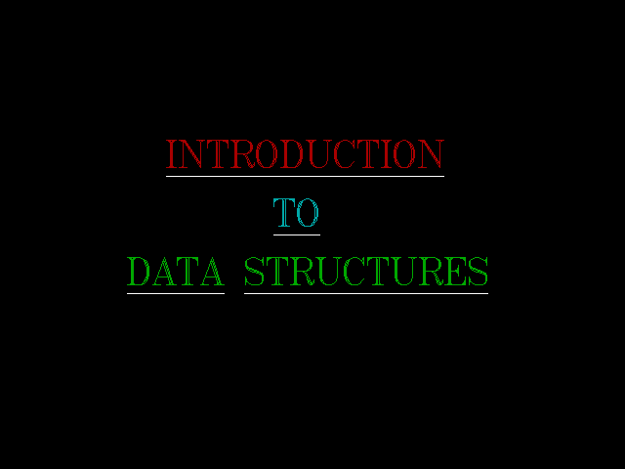

MAIN SCREEN

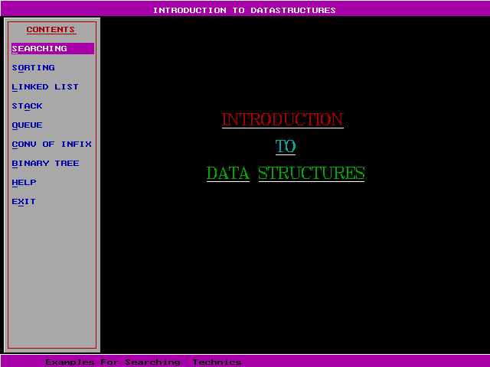

LINEAR SEARCH SCREEN

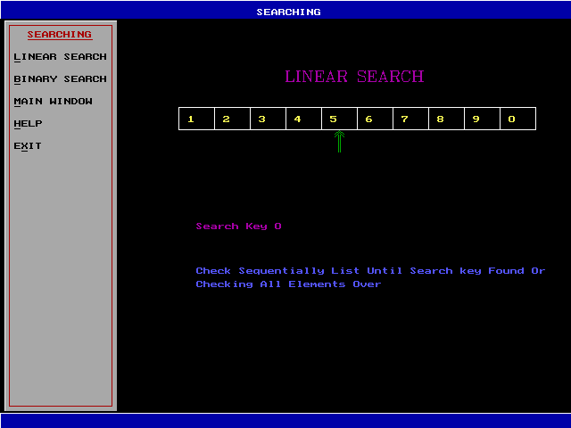

BINARY SEARCH SCREEN

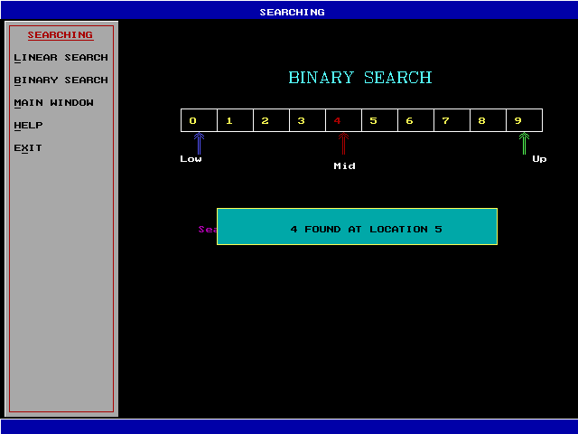

LINEAR SORT SCREEN

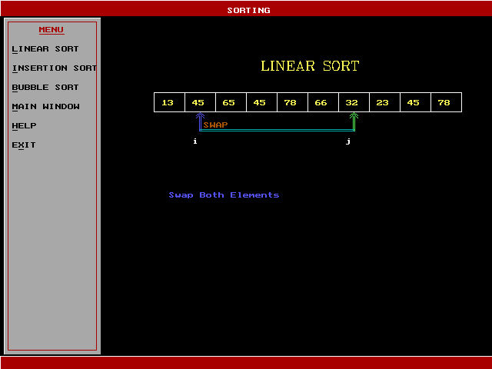

INSERTION SORT SCREEN

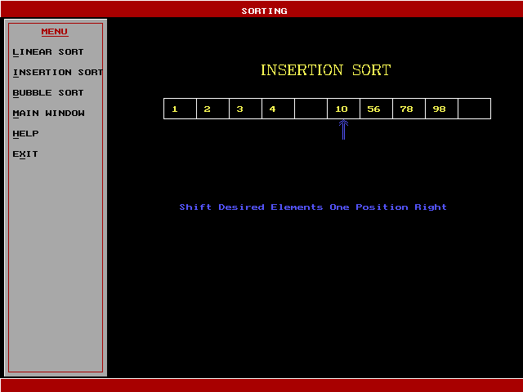

BUBBLE SORT SCREEN

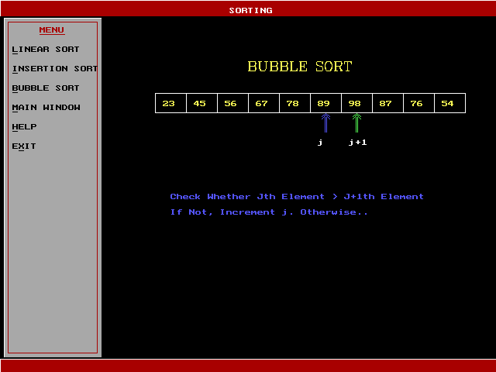

DOUBLE LINKED LIST SCREEN

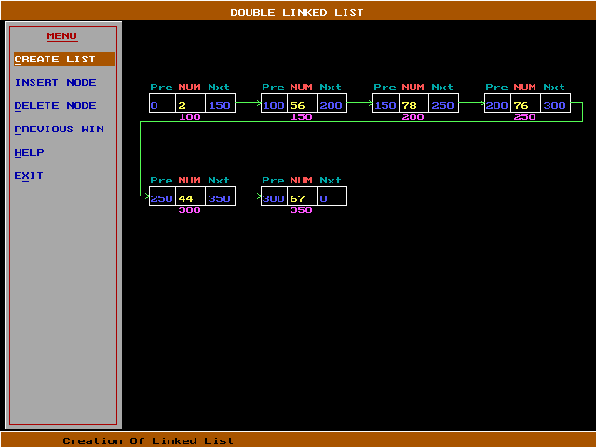

SINGLE LINKED LIST SCREEN

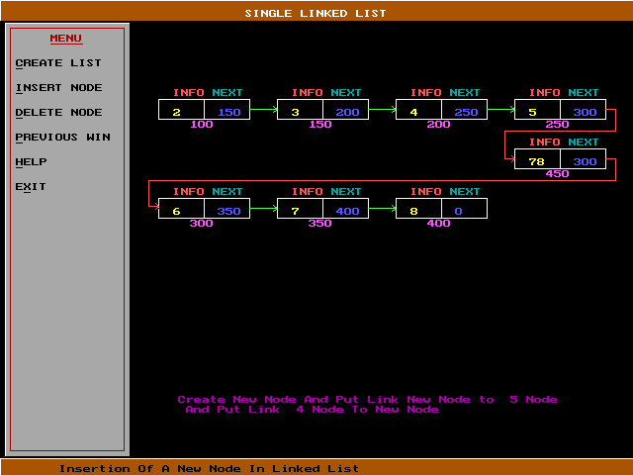

STACK SCREEN

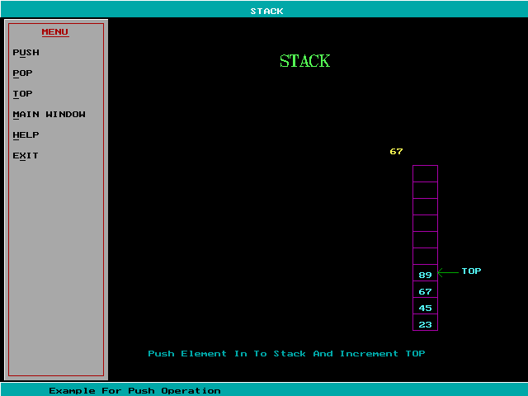

QUEUE SCREEN

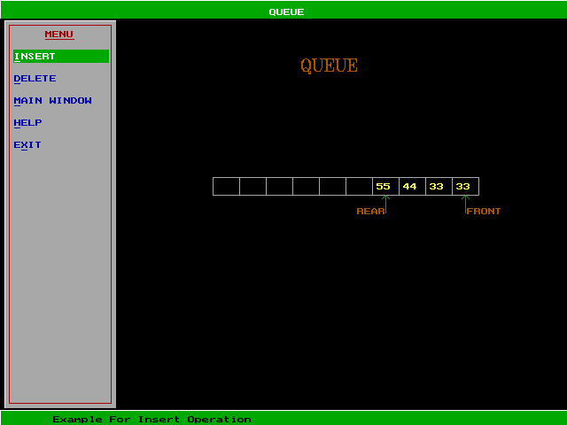

PREFIX SCREEN

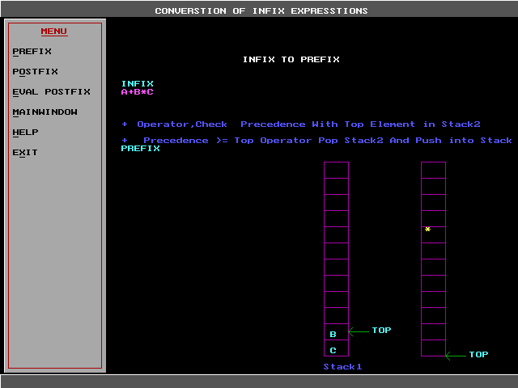

POSTFIX SCREEN

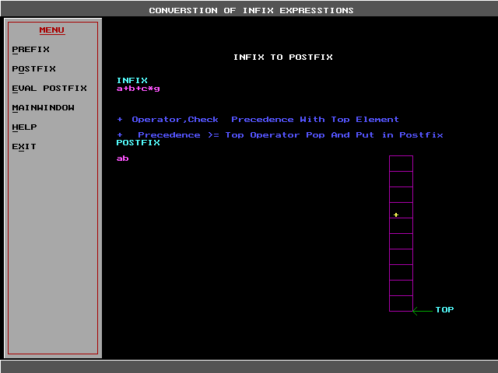

EVALUATION OF POST FIX SCREEN

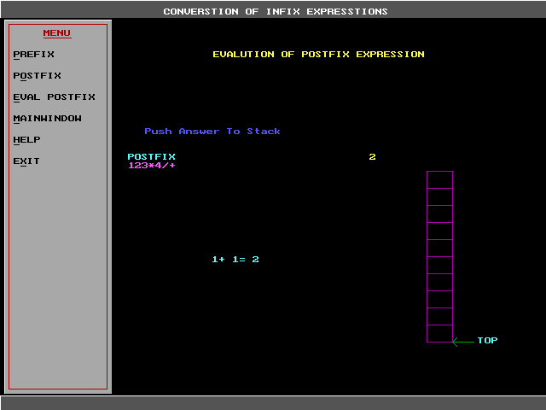

BINARY TREE SCREEN

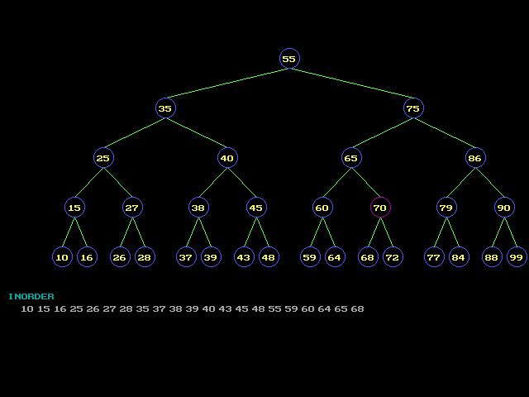

HELP SCREEN

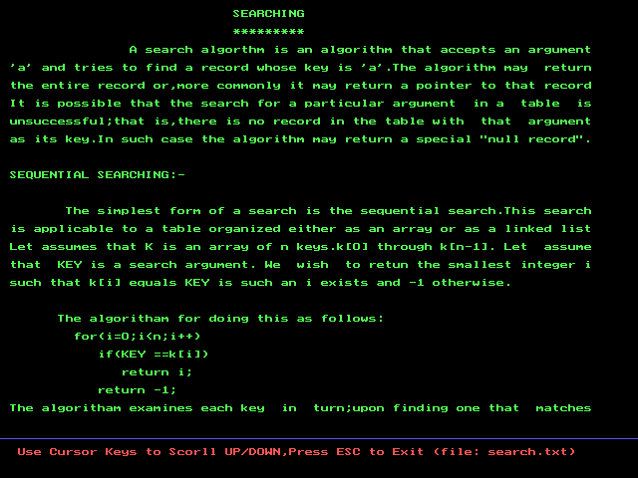

BACKGROUND OF THE ORGANIZATION:

Nexgen Technologies Ltd was established in May 1997 in Hyderabad and very soon became the pioneers of the online educatiuonal system. They have started a educational portal named Getcet.com which became one of the famous portals for educational training. At the same time they are well known for their development projects on C and C+. They are having development centers in Chennai, Bangalore and Newdelhi. Right now the company is well established with more than 500 employees.

The main resourse of the organization is the manpower they are having whom they will recruite through typical tests and interviews and an extensive corporate traianing will be given to those people. Having very good administrative and technical team it is sure that the company will become one of the good companies in India.

Bibliography

- Data Structures Using C And C++

- Yedidyah Langsam

- Moshe J. Augenstein

- Aaron M.Tenenbaum

Programming In C

- Stephen G. Kochan

